**Introduction to Artificial Intelligence and Machine Learning**

**Introduction to Artificial Intelligence and Machine Learning**

We will begin to introduce to you both artificial intelligence and machine learning. In this overview, we will discuss how to properly define what the precise definitions are for artificial intelligence, machine learning, and deep learning, and how to differentiate between the three. One hint I want you to know off the bat is that deep learning will be a subset of machine learning, which in turn will be a subset of artificial intelligence.

To understand the depth of where artificial intelligence has brought us in recent history, two of the biggest breakthroughs which we will continue to touch on as we go through the history of artificial intelligence are an **image processing** and **machine translation**.

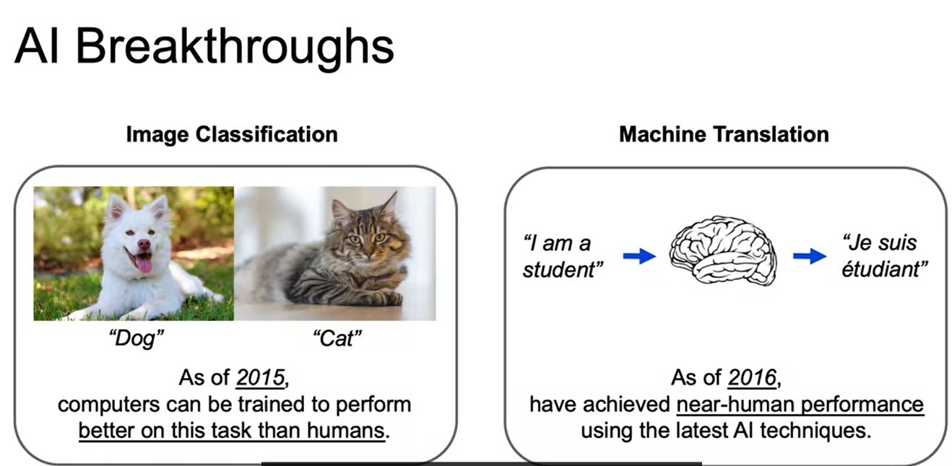

To understand the **image classification**, imagine we are given this task to identify which one of these pictures is a dog and then which one of these pictures is a cat. And going back to 2015, computers have been able to do a better job of classifying such images into categories than humans. For **machine translation**, our goal is to take a phrase or sentence in one language, such as I am a student. And then give the translation in another language, keeping in mind all the intricacies of word ordering and proper phrasing of that other language, which we have here in French. And incredible work is being done so that machines can translate to near-human performance. Now, these are very tough problems for classical machine learning models. For images, it was hard to identify useful features. And then for natural language processing, translations are, as we discussed, not as simple as just going word by word. But keeping into account the word ordering, and the proper phrasing, and the common use within different languages. Now, advancements in deep learning, as well as innovations in the realms of data storage and processing power, have given us this ability to step up and start to have this capability to now push past these machine learning models, these classic machine learning model barriers.

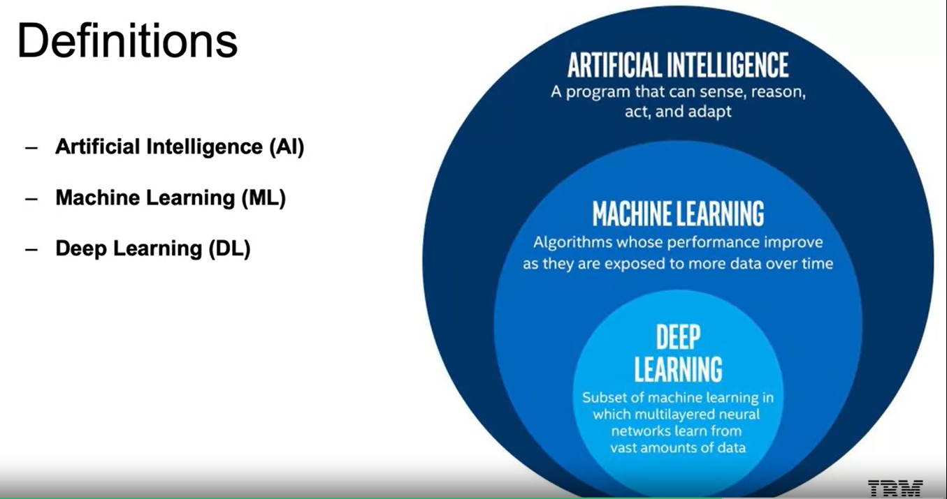

**Deep learning** is a subset of **machine learning**, and machine learning, a subset of **artificial intelligence**. If we look at the definitions, we have written out here, we see that:

* **Artificial intelligence** is any program that can sense, reason, and act and adapt. It is essentially a machine taking any form of intelligent behavior.
* **Machine learning** is a subset of that, where it's able to replicate intelligent behavior, but the machine will learn as more data is exposed to it.
* **Deep learning** is a subset of machine learning. Meaning it will also improve as it's exposed to more data, but now specifically to those algorithms which have multi-layered neural networks.

Merriam-Webster Dictionary defines artificial intelligence as a branch of computer science dealing with the simulation of intelligent behavior in computers. So very similar to what we just mentioned, any means of simulating intelligent behavior. According to Wikipedia: “colloquially, the term artificial intelligence is applied when a machine mimics cognitive functions that humans associate with other human minds, such as learning and problem solving”. When we use the term artificial intelligence in our day-to-day, we see a very similar definition to what we have here and the idea that intelligence is defined as human intelligence. This has its roots in the historical coining of the term artificial intelligence and ties to the Turing question, which we'll discuss as we dive into the history of artificial intelligence. Just to make clear what would be an example of artificial intelligence that doesn't necessarily fall under our subsets of machine learning and deep learning. That would be something like a rule-based system where it doesn't learn as more data comes in.

**Machine Learning and Deep Learning**

Machine Learning is the study and construction of programs that are not explicitly programmed, but rather learn patterns as they're exposed to more data over time. Machine Learning is going to be a subset of Artificial Intelligence. It's going to be a subset that's going to learn from observing data. The more data, the better the algorithm can learn the underlying patterns.

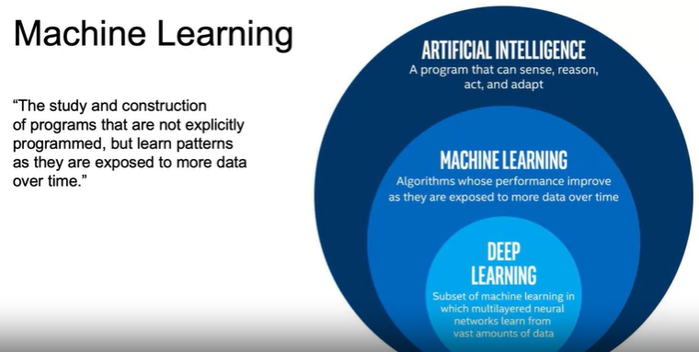

In general, the idea is going to be that as we gain more data, Machine Learning is going to be able to better understand the underlying patterns. So, these programs learn from repeatedly seeing data rather than being explicitly programmed by humans. So, it's not going to be a set of rules programmed by humans to make a decision.

As an example, let's say we're working with trying to decide whether emails are spam or not spam. We would start off with a dataset where we have a bunch of emails that are going to be labeled spam versus not spam. These emails will be preprocessed and fed through a Machine Learning algorithm that learns the patterns for spam versus not spam, and the more emails it has to learn the underlying patterns the better the model is going to get. Once the machine algorithm is trained, we can then use it to predict as new emails are coming in. So, we trained on this label dataset, and now we can run in production and as new emails come in, we can predict spam versus not spam.

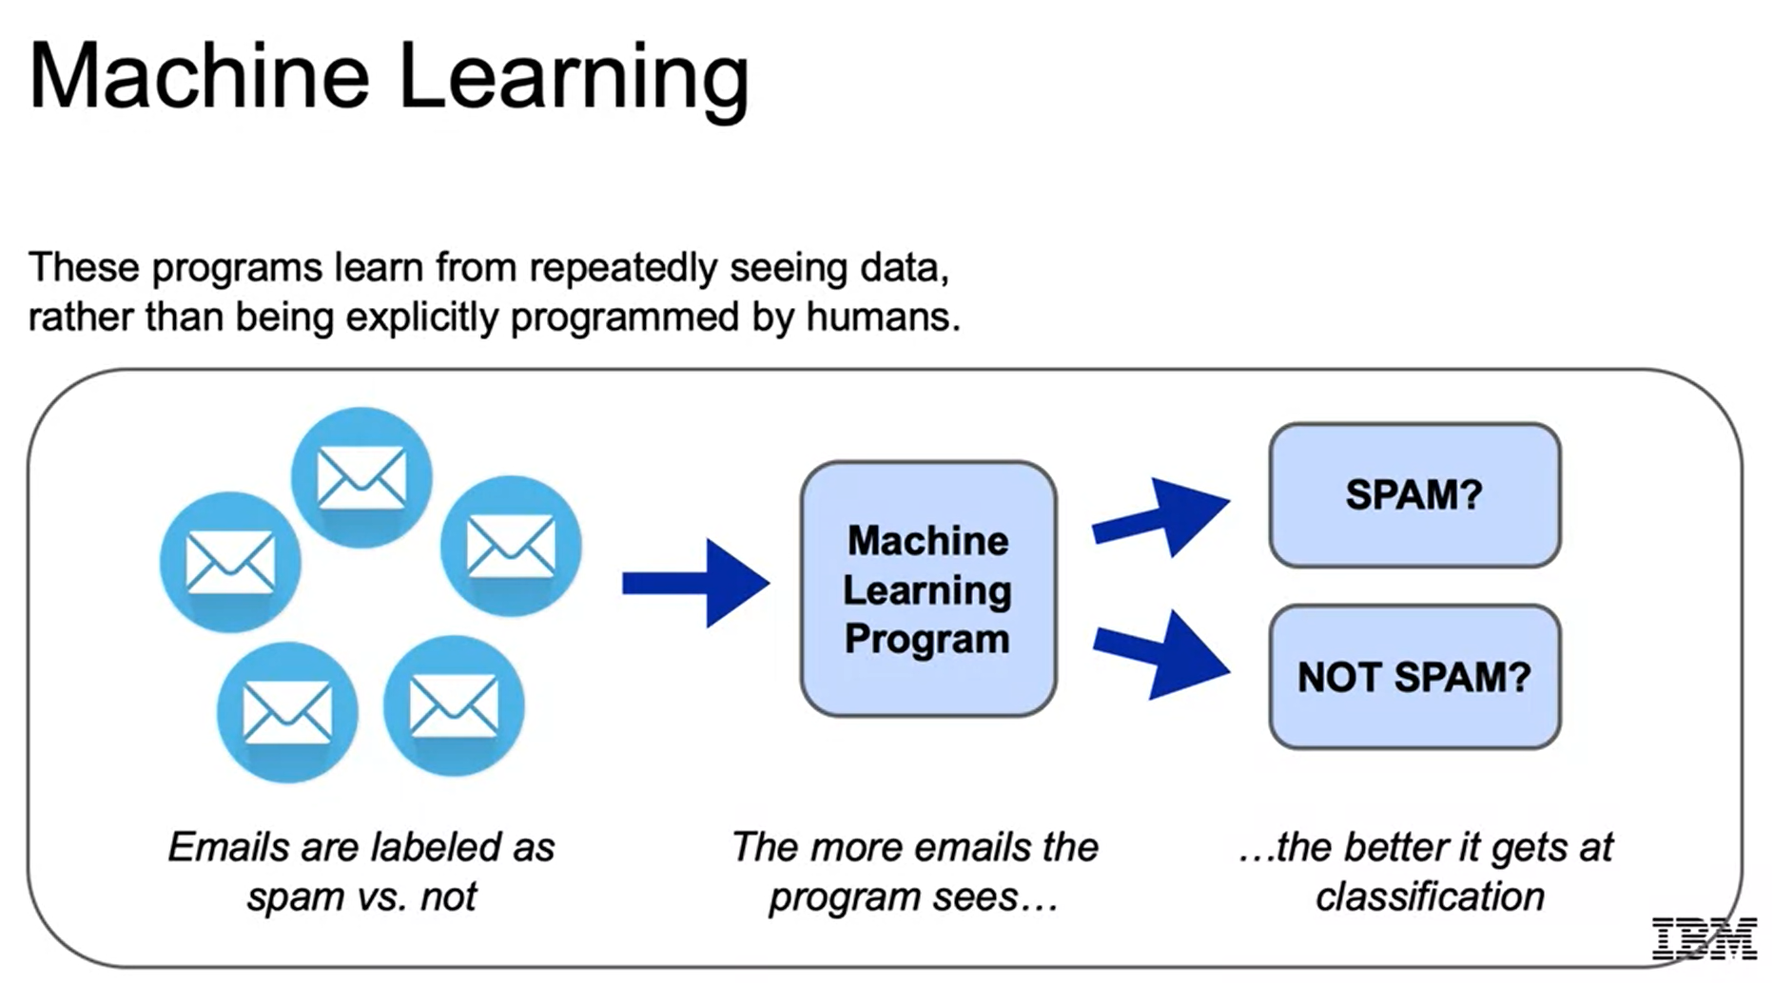

Now we're going to use a simple dataset just to highlight what **features** are and what a **target** is. Features and target are going to be important terms for us to understand. The iris dataset is a popular dataset often used to introduce basic concepts in Machine Learning. So, the iris here is going to be a flower that comes in three species as you see here: virginica, setosa, and versicolor, and **that's going to be the target that we're trying to predict**. So, our dataset here contains **four features**: *sepal length and sepal width, petal length and petal width*. Those are going to be the features we will use to make our prediction. Then again as I mentioned before, the target variable is going to be the column that we're trying to predict. The idea is to use the four features, sepal length, sepal width, petal length, and petal width in order to predict the species and then moving forward if we had those four features, we would be able to predict the species without the label.

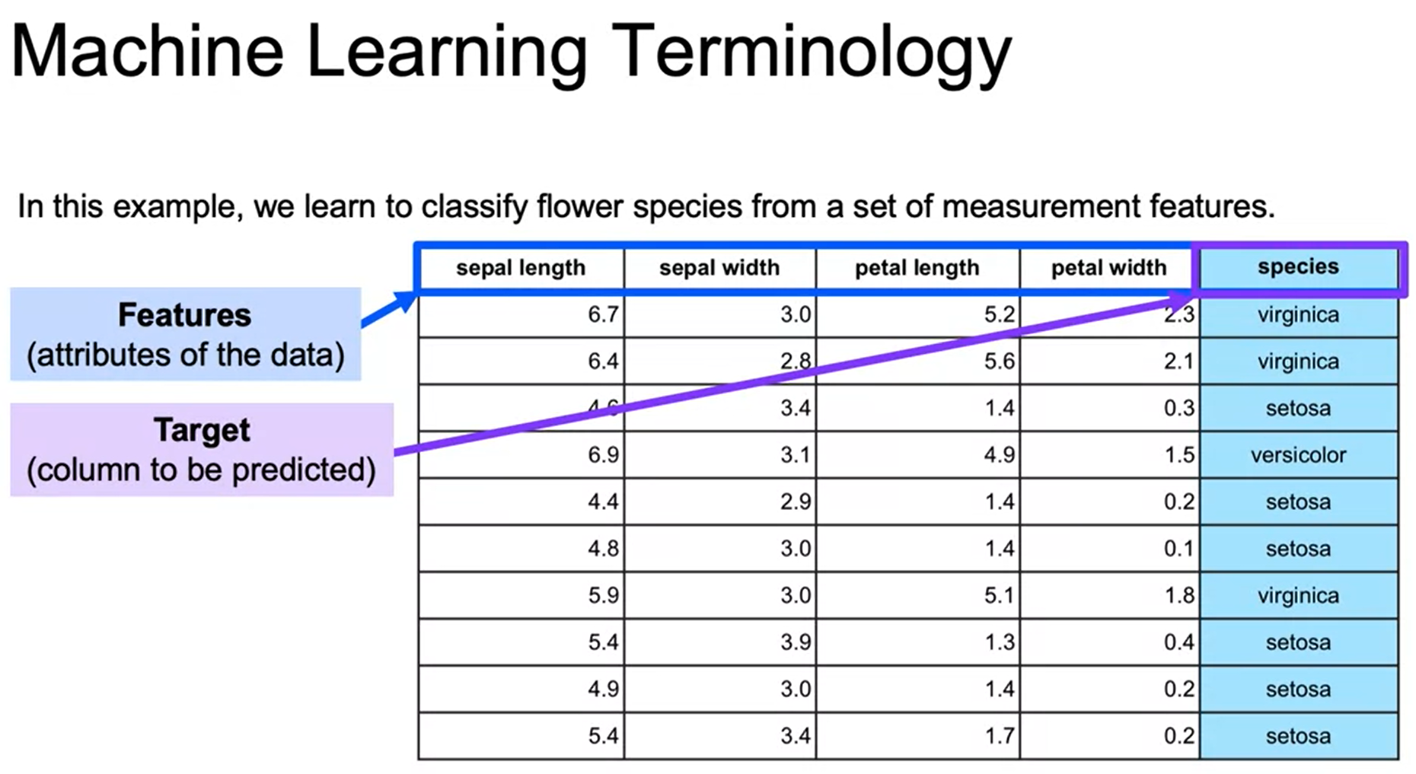

In general, there are two types of Machine Learning. There are **supervised learning** and **unsupervised learning**. For supervised learning, we will have a target column or labels like what we just saw with the email spam and iris flower classification examples, and then for unsupervised learning on the other hand we will not have a target column.

The goal for supervised learning is going to be able to predict that label. Is it spam or is it not spam? Is it's versicolor or another one of the different flower species? For unsupervised learning, the goal is going to be to find an underlying structure of the dataset without any labels, and this will be clear with our examples. An example of supervised learning is fraud detection. We may have a large dataset where we have labels of either this transaction is fraud, and this transaction is not fraud. We would learn from all the features related to fraud detection and be able to predict as new credit card transactions come in whether those are fraud or not fraud. For unsupervised learning, an example would be customer segmentation. For this, you can think about customer segmentation to find similar groupings within your dataset for a marketing campaign, you have this e-commerce data, and you want to separate them out into groups in order to target them accordingly. For unsupervised learning, there's going to be no right or wrong answer. So, the user will need to test different models and see which results tend to make the most sense.

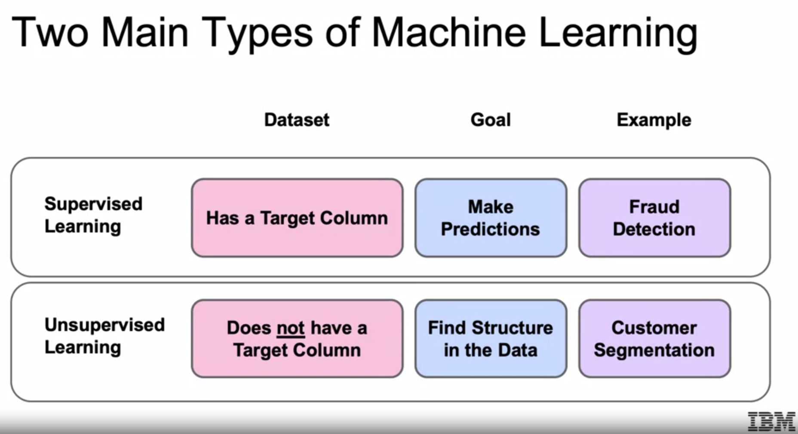

Suppose you wanted to identify fraudulent credit card transactions, detecting fraud is going to be a common Machine Learning problem. You can define your features to be transaction time, transaction amounts, transaction location, category of purchase. Combining all these features together, we should be able to predict in the future with transaction time, the amount location in the category of purchase, whether there's unusual activity, and whether this transaction is fraud versus not fraud. This structured data with intuitive features are going to be a good task for our traditional Machine Learning.

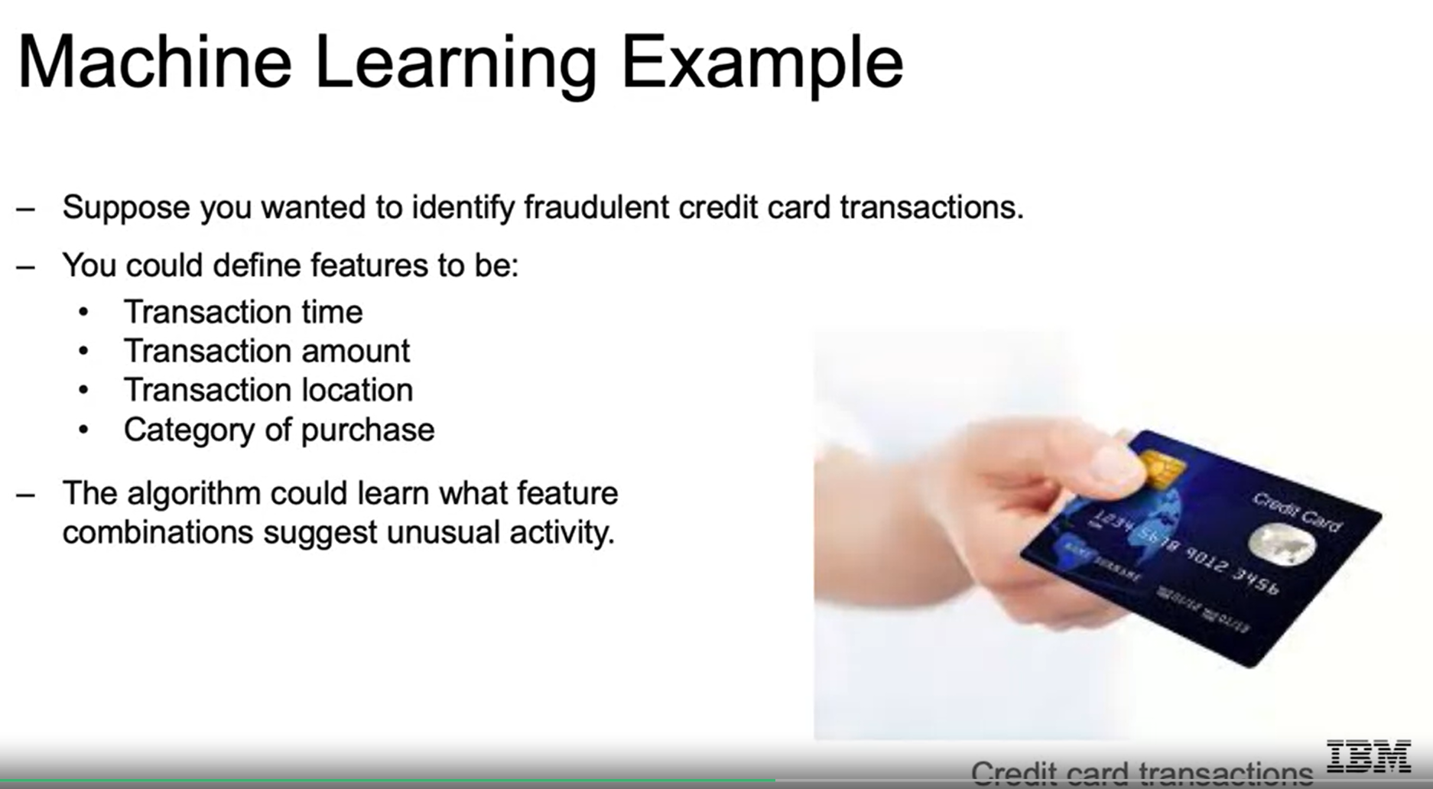

Now, defining features in an image, on the other hand, is a much more difficult and involved task and has been a defining issue of the limitations of our Traditional Machine Learning techniques that Deep Learning has now done a good job of addressing. So, suppose you want to determine if an image is a cat or a dog, so what features should we use? For images, the data is taken as numerical data to reference the coloring of each individual pixel within our image. A pixel then could be used as a feature. So, we saw the features before in our dataset. But if you imagine even a small image will have 256 by 256 pixels, which will come out to over 65,000 pixels. Sixty-five thousand pixels mean 65,000 features which is a huge number of features to be working with. Another issue is that using each pixel as an individual, you lose the spatial relationship to the pixels around it. In other words, the information of a pixel makes sense relative to its surrounding pixels. So, you have the different pixels that make up the nose perhaps, or the different pixels that make up the eyes, and then separating that out according to where they are in relation to the face, so on and so forth. This is where Deep Learning can come in. Deep Learning techniques will give you the capability to learn these features on its own and combine these pixels to define these spatial relationships.

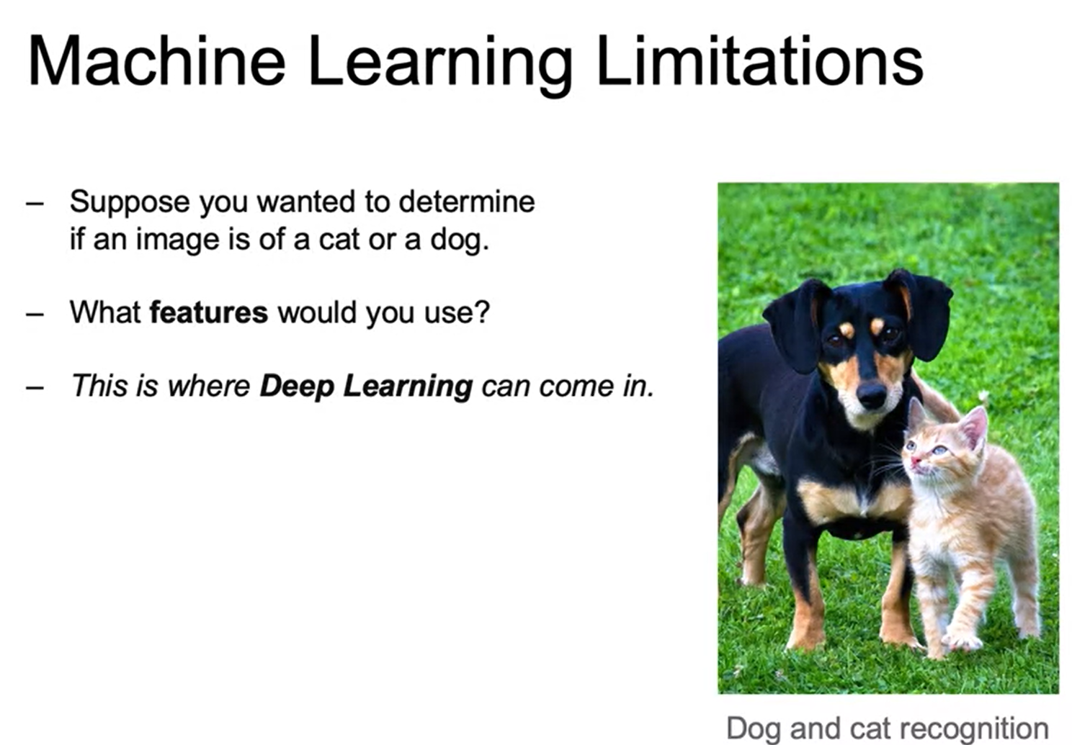

Deep learning is going to be Machine Learning that involves using very complicated models called deep neural networks. The models themselves will be able to determine the best representation of our original data. In classic Machine Learning, humans must come up with these features and this will allow us to solve complex problems such as what we just saw with the image classification. Deep Learning is the cutting edge and is where most of Machine Learning research is focused as blown away the performance of other algorithms when you're dealing with larger datasets. But it is very important to note that you'll often be working with smaller datasets, and standard Machine Learning algorithms will often perform significantly better than working with Deep Learning techniques. Also, if the data is changing a lot over time and you don't have a steady dataset, again Machine Learning will probably do a better job of being able to have better performance over time.

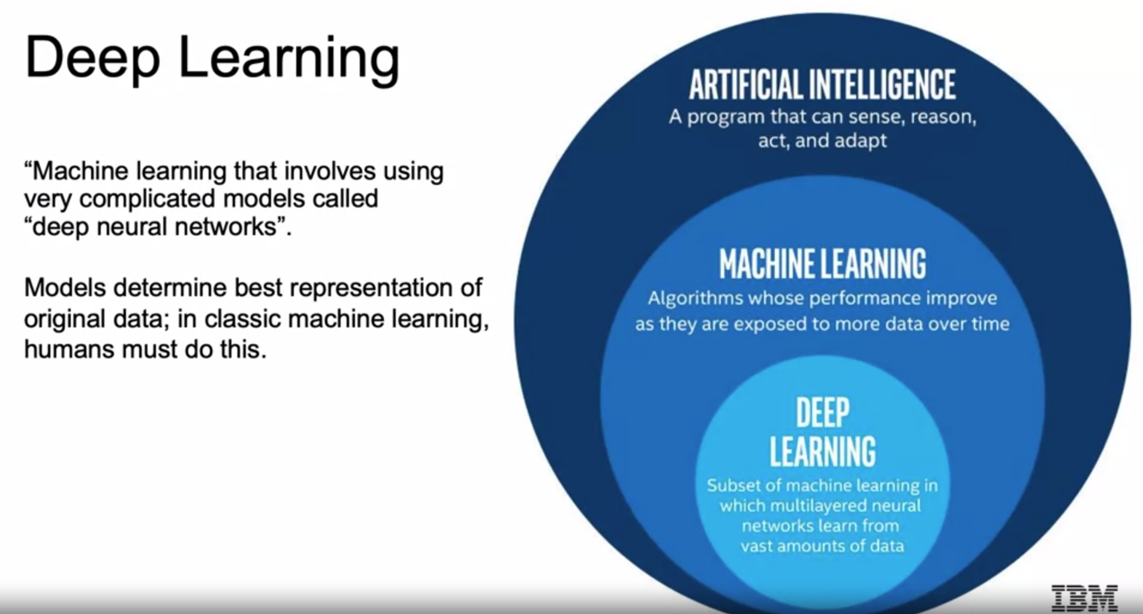

In the Classical Machine Learning model, we are going to have to define these features ourselves a priority before we feed the data to our actual model, so determining the features that make up the nose, the eyes, so on and so forth. We can then use the features and include them in a Machine Learning algorithm. If a data scientist is lucky, he may be able to guess good features, but this is a really challenging to do well. Then they can use that to predict that this is a picture of Arjun. Now Deep Learning will combine this two-step process. The neural network receives these pixels of an image as an input. The neural network learns how to extract these features that are meaningful from the image by combining them together in different complex combinations. Now, these features may not always make much sense when we try to interpret them in these intermediate layers. But ideally, they will first highlight edges and then combine those edges to make up shapes like nose, eyes, lips. But whether the intermediate steps are interpretable, they can be very useful for completing tasks such as image classification and coming up with the intermediate feature engineering steps, and then eventually predicting Arjun.

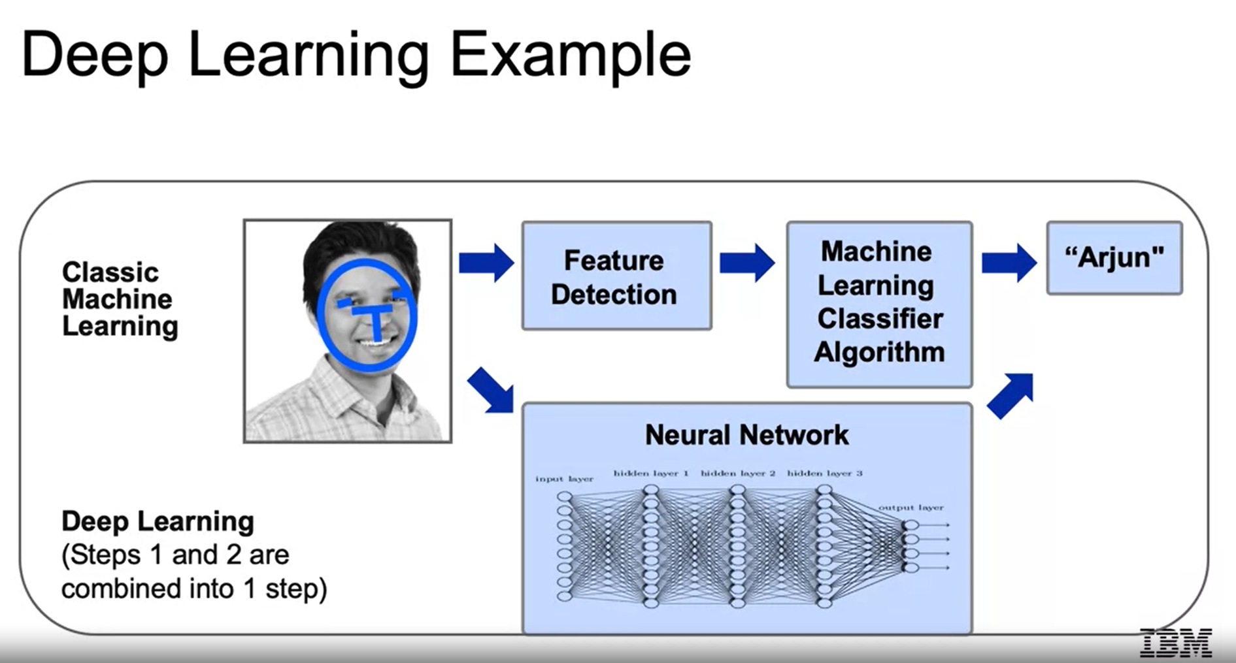

**History of AI**

AI has gone through several cycles where there have been both significant amounts of investments and excitement, as well as large walls in these investments as well as the excitement.

So, going from earlier algorithms and the initial excitement, as the term artificial intelligence was officially coined, and the first investments and promise began to be discussed on a larger scale in the 1950s. We then in the 1960s and 1970s, hail our first AI Winter, as the old failed to live up to the promise of the initial expectations. Then in the 1980s, AI got its second boom as businesses found it possible to utilize rule-based algorithms, called expert systems to aid in decision-making. Along with that, many theoretical breakthroughs introduce the promise behind neural networks. But then as promised, we had another AI Winter. In the late 80s and into the 90s, another failure to be able to leverage the promise of the expert systems and neural networks, and practical applications led to another decrease in investments. Then in the late 90s and early 2000s, machine learning proved to be successful in many tasks, such as speech recognition, Google's search algorithm and many others. And then finally, fast-forwarding to today, there were major breakthroughs in deep learning proving to be able to overcome many of the historical practical limitations of the initial neural networks. And they began to outperform classical machine learning techniques in many complex big data problems, such as image classification and machine translation. So, we see this up and down, and then finally hear this excitement around deep learning as they able to accomplish all these tasks that were once set with such high bar when we first started to think about artificial intelligence.

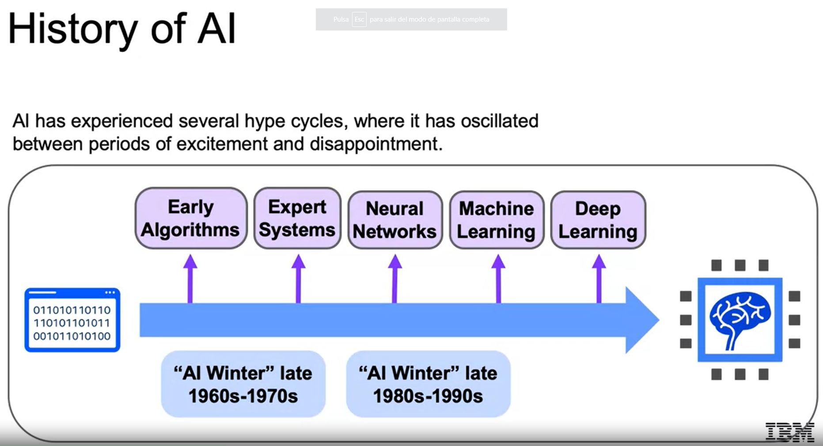

Let's go all the way back to the beginning. In 1950, Alan Turing developed the Turing test to test a machine's ability to exhibit intelligent behavior. Alan Turing's test has served as a foundational threshold for artificial intelligence. The idea being, will a computer ever be able to sufficiently imitate a human to the point where a suspicious judge cannot tell the difference between human and machine? In 1956, Artificial Intelligence was accepted as a field at the Dartmouth Conference. With this conference, researchers from various fields excitedly agreed that artificial intelligence, that is the simulation of intelligent behavior in computers, was indeed achievable. In 1957, Frank Rosenblatt invented the perceptron algorithm, which is the precursor to our modern neural networks. And it generated a ton of excitement in the field, as it showed how one can come up with a model that learned from data fed into the machine. And then in 1959, Arthur Samuel published an algorithm for checkers program, which was intelligently built according to the limitations of computation at the time obviously, to learn from the current state of the board and the positions at seen in the past to come up with the next move.

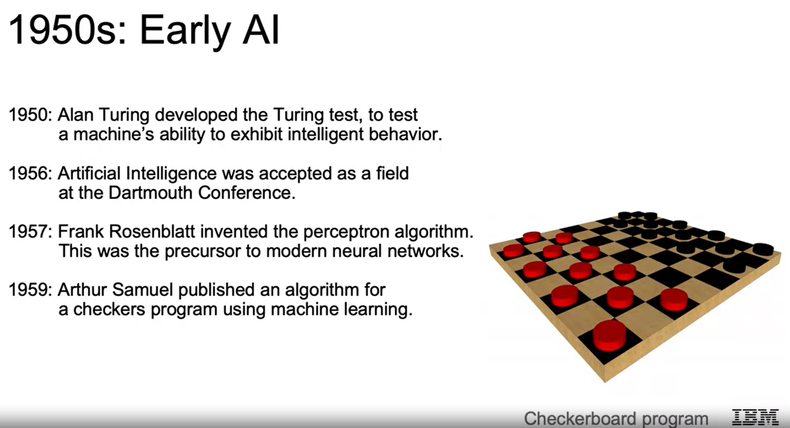

As promised following this excitement, we face our first AI Winter. During the Cold War, machine translation, specifically between Russian and English, was one of the major goals in artificial intelligence. In 1966, a committee was formed of seven scientists, put in place by the US government, specifically to assess the progress of machine translation. And this group deemed there was very little return on investment, dealing a major blow to the hype around artificial intelligence. Then in 1969, Marvin Minsky's work identified major limitations to Rosenblatt's perceptron algorithm, dealing yet another blow to artificial intelligence. In 1973, the highly regarded British applied mathematician, James Light hill published a report highlighting how discoveries and research have fallen well short of the high hopes laid out over the past few decades, leading to government's cutting back much of their funding in artificial intelligence research.

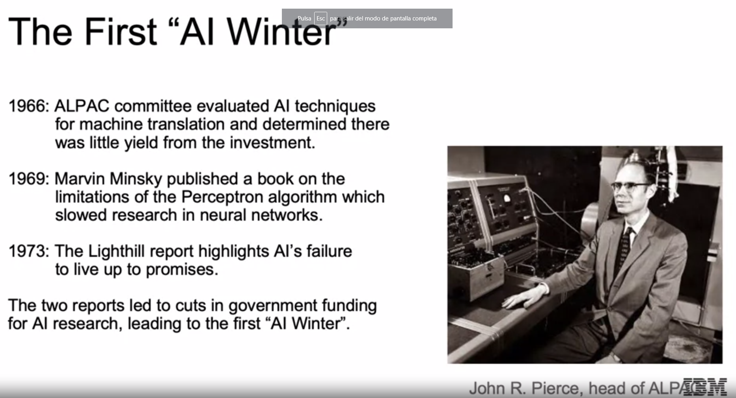

Then as discuss, we have our winter, then we have our next boom. In the 1980s, expert systems became all the rage. These systems were built with programmed rules designed to mimic human experts, the idea being too hard code the machines with facts and rules representing expert knowledge of different subjects. These programs ran on powerful mainframe computers using specialized programming languages, such as LISP, which is one of the oldest high-level languages and was the most popular for artificial intelligence research at its time. These expert systems gained huge popularity. And AI infiltrated the business world at a large scale for the first time here in the 1980s. And then on another note, another significant event in the history of AI during this time, was Geoffrey Hinton and others published works explaining the Backpropagation algorithm, possibly, the most important algorithm for deep learning, which allowed for multi-layer networks to better update its parameters using the data given. This drove a huge excitement in the fact that researchers could now theoretically learn complex multi-layer models that can actually learn from new data.

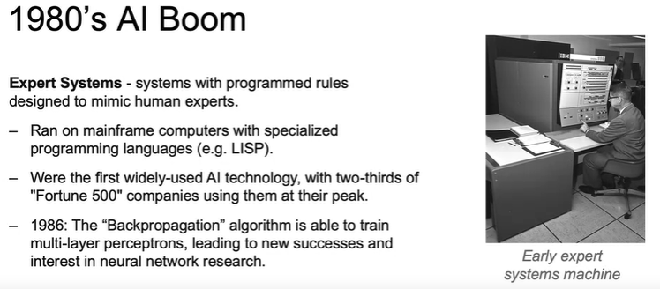

And then we hit our next AI Winter in the 80s and 90s. Expert systems' progress on solving business problems slowed, major reasons being their inability to learn, also they were finicky. They could make terrible mistakes when they received abnormal inputs. Expert systems began to be melded into software suites of general business applications that could run on PCs instead of mainframes. So, the investment in large mainframe computer subsided, as much of their capabilities were incorporated into these regular desktops. Neural networks didn't scale to large problems. The Backpropagation algorithm that generates so much excitement faced many problems with implementation of problems with large data sets and large networks. And then with these in mind, the excitement behind utilizing artificial intelligence for business once again subsided.

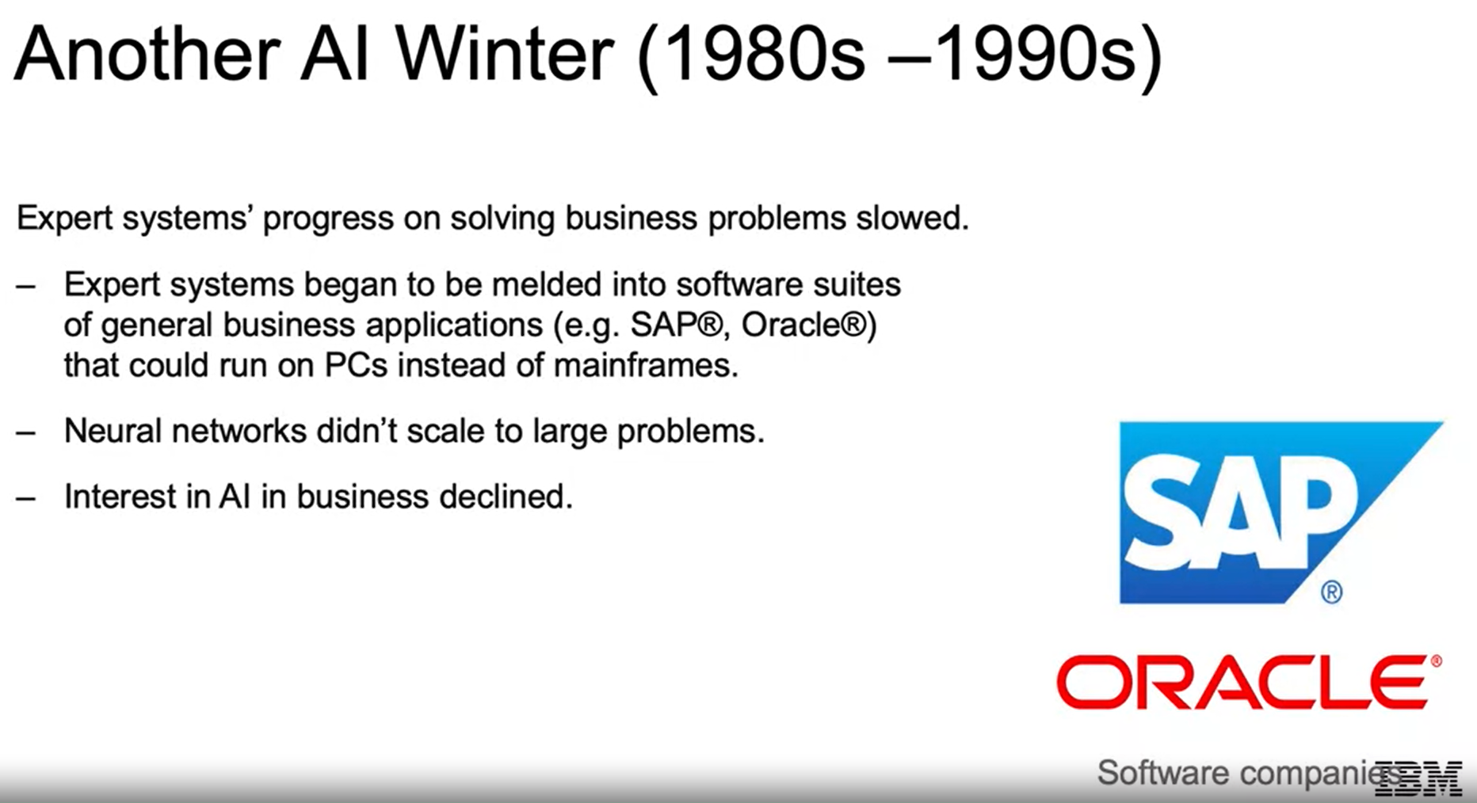

**History of Machine Learning and Deep Learning**

We're in the 90s and 2000s, and AI solutions using classical machine learning techniques began to take off. AI solutions had successes in speech recognition, medical diagnosis, robotics, and many other areas. AI algorithms were integrated into larger systems and once again, became useful throughout industry. In 1996, Deep Blue accomplished the major feat of being the first machine to defeat a world champion chess player. So, you can imagine the hype and excitement as a machine is able to beat a human in chess for the first time. Also, Google revolutionized the search engine space with its PageRank algorithm to display search results.

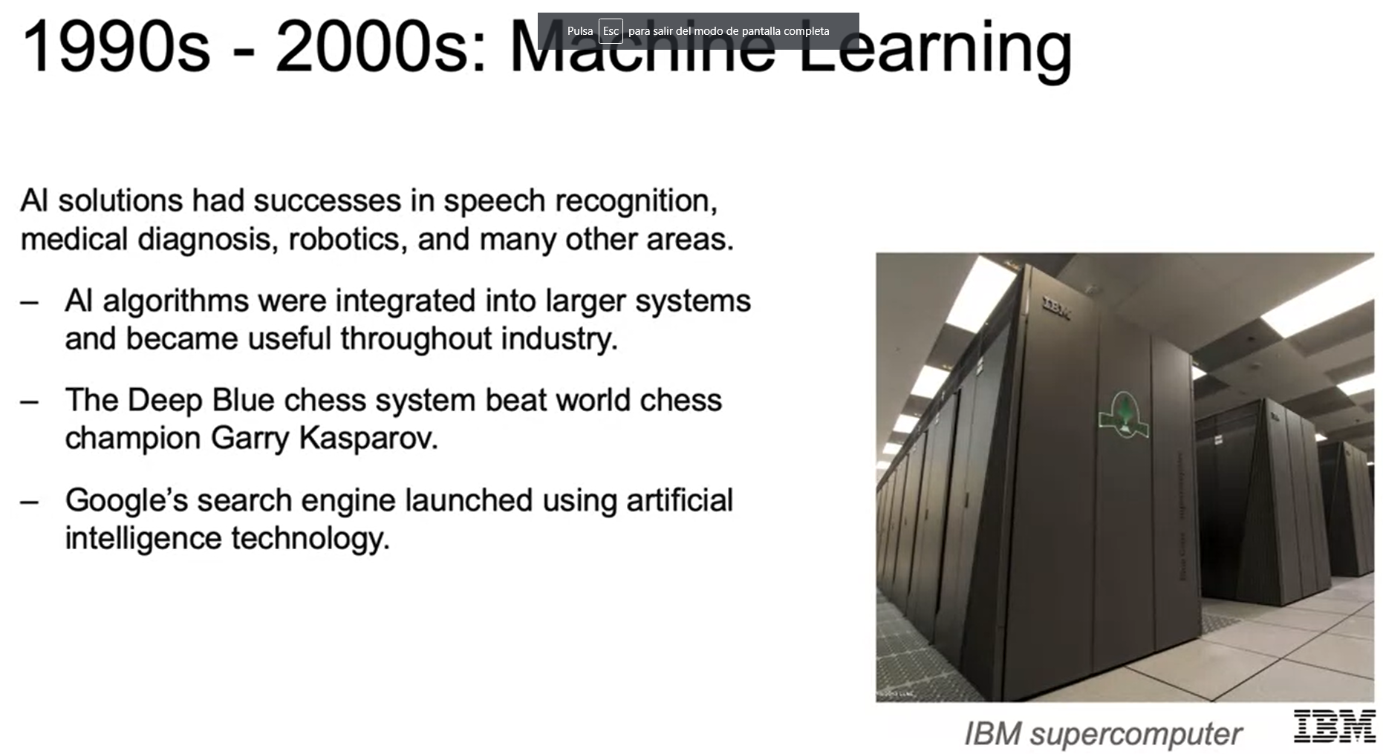

In 2006, the previous limitations of deep learning, namely exploding and vanishing gradients, which we'll touch on later in the course, were overcome with algorithmic advancements such as Geoffrey Hinton's work on unsupervised pre-training. Neural networks are rebranded as deep learning, as we can train much deeper networks, networks with more layers. In 2009, the ImageNet database was introduced, which was a groundbreaking data set that provided millions and millions of labeled images, which were not available before, today to practitioners. Then in 2010, algorithms compete on several visual recognition tasks at the first ImageNet competition. This greatly increased the opportunity for an algorithm to try and learn from many examples, the complexities of the patterns that make up a cat or a dog, or even a certain breed of dog.

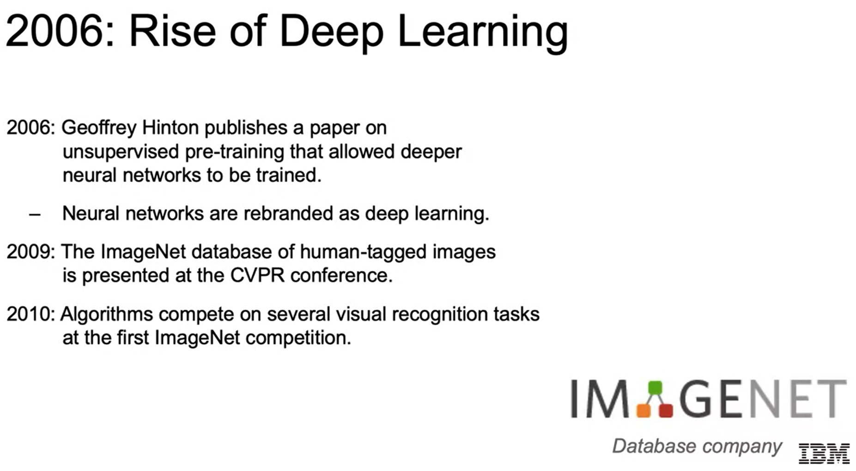

In 2012, a deep learning model using convolutional neural nets called AlexNet achieved a top five error of 15.3 percent, blowing out the competition that was more than 10.8 percent points lower than the next lowest error. So, from there, the practical applications for deep learning began to take off. In 2013, it was used to give description of the conceptual meaning of words by learning from copious amounts of written data. In 2014, we saw similar breakthroughs in the task of machine translation, leveraging concepts such as recurrent neural nets, making what was once one of the major goals in the 60s, if you recall that was one of the causes of the first AI winters, an actual reality. These have led to advancements in web search, document search, document summarization, and machine translation.

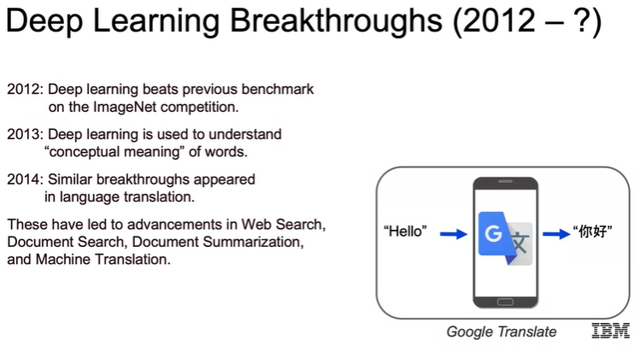

In 2014, Stanford researchers elevated computer vision to another level with the ability to annotate photos with captions such as baseball player throwing a ball in game, rather than just saying this is a human, it's able to give a bit of a story behind an actual picture. In 2015, one of the most popular libraries, TensorFlow, was built for deep learning, making it more powerful and accessible. In 2019, this was made even more accessible while gaining even more flexibility and power as well, with version 2.0 incorporating the high-level libraries Keras, which we'll touch on later. In 2016, DeepMind's AlphaGo was able to defeat a Go master, a game considered much more difficult than chess due to the prohibitively large number of possibilities for every single move. In 2018, Waymo, the self-driving car taxi service launched by Google, began giving rides in the suburbs of Phoenix. In 2019, the IBM Project Debater put on a fascinating debate with a champion human debater, showing the ability to argue a topic, listen to a human response, and then give a rebuttal accordingly. Those are just some of the many major highlights of where we are today with artificial intelligence.

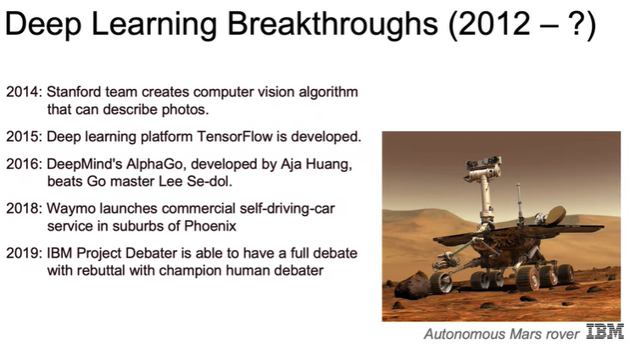

**Modern AI: Applications and the Machine Learning Workflow**

**Modern AI**

So where are we today? Two spaces where seeing drastic growth and innovation are computer vision and natural language processing. The sharp advancements in computer vision are impacting multiple areas. Some of the most notable are cars getting to the point where they can drive themselves. In healthcare, computer vision is now used to review different imaging modalities, such as x-rays and MRIs to diagnose illnesses. We're fast approaching the point where machines are doing as well, if not better than the medical experts. Similarly, natural language processing is booming with a vast improvement in ability to translate, determine sentiment, clustering of new articles, writing papers, and many others.

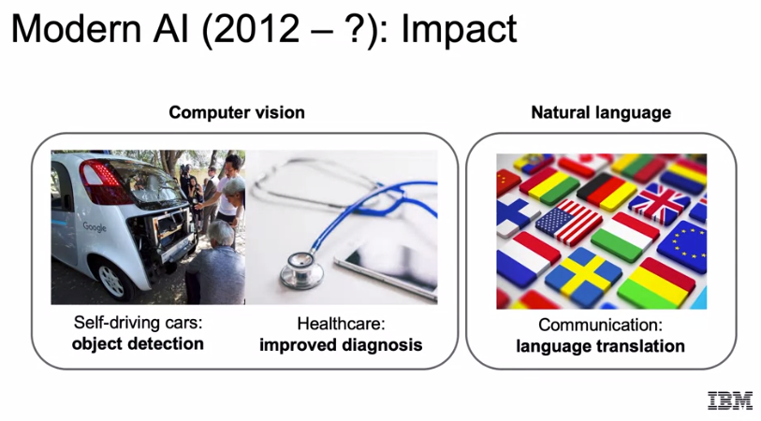

Does this era of AI different? Main factors are bigger datasets. We now have larger and more diverse datasets than ever before. We talked about how ImageNet and how that was able to open the opportunities to train models that need larger datasets to learn complex patterns. With the Cloud infrastructure now in place to store copious amounts of data for much cheaper, and the plethora of new ways to capture data are now able to build larger, more new once datasets to learn underlying patterns across a multitude of fields. We have faster computers. We now have access to powerful hardware for processing and storing data. The mainframe computers used to first drive the expert systems in the '80s costs about $200,000 a month. We can now get stronger and faster computers that sit on our laps. Neural networks have finally taken off in the past decade and proven to be successful. We have had constant innovation in the area of deep learning leading to practical results within the industry. All this is leading to cutting edge results in a variety of fields. So, we can think about with our phones, how we're able to use our face to unlock our phones, how they recognize our voice, how it's able to look at pictures and identify pictures of us or our friends. We have stores where we can walk in and pick things up such as Amazon Go and not have to go to a checkout counter. We have our homes being powered by our voice telling it we want music played or for the lights to be switched on or off. All of this has been driven by this current era in artificial intelligence.

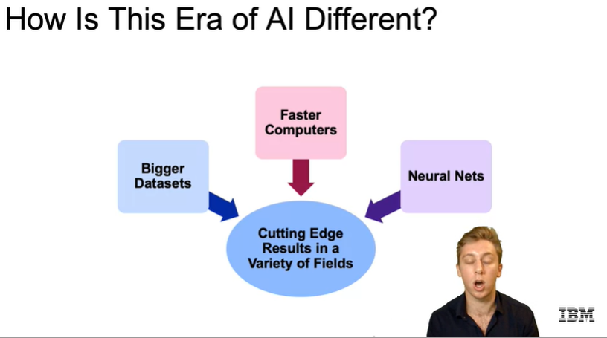

Within healthcare, as discussed, AI is now used to aid in medical imaging. Often computers can diagnose as accurately or even more accurately than medical professionals. For drug discovery, a great example is Pfizer has turned to IBM Watson to leverage machine learning to power its drug discovery and search for immuno-oncology drugs. Patient care is being driven by AI, as well as AI research within the healthcare industry and has helped advance sensory aids for the deaf, blind, and those that have lost limbs. In industrial, we can now automate factory work for efficiency and lower costs. We can monitor for future system failures and schedule maintenance in advance, able to enhance and optimize agricultural production. Field automation can track our sales, inventory, and delivery needs at a much quicker pace.

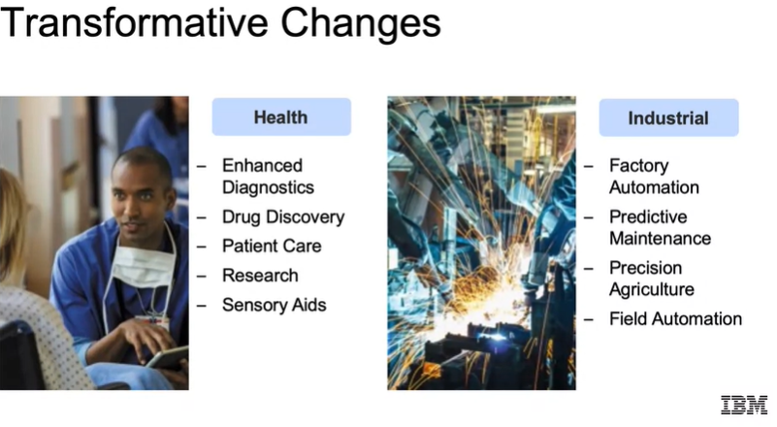

For finance, we have algorithmic trading, fraud detection, research, our personal finance, risk mitigation, all being driven by AI. For energy, it's being used to locate and extract oil and gas reserves. We have smart grids which essentially are meant to optimize electrical grid for more efficient infrastructure. We're also able to improve overall operations within the industry and we also are learning to conserve energy using artificial intelligence. Within government, defense and identifying threats. Think about our cold war example and where we are today. Gaining insights for all major issues, whether they are threats from weather or pandemics, or simply gaining a better understanding of their citizen’s needs. We have a driving safety and security as they have more access to data from both abroad and at home. It's able to enhance their engagement between government and citizens. It's aided in building smarter cities to optimize things such as traffic, healthcare, police and fire protection, and the distribution of energy. Transportation, we have autonomous cars, automated trucking for deliveries. AI is huge in aerospace to optimize simulations, maintenance, and prototyping. It's able to come up with optimal routes and timing for shipping. AI has helped in the search and rescue fields with drones now being built up machine learning algorithms to help search and detect missing people in areas that may be too dangerous to initially explore by humans, and so much more. We have personalized advertisements, personalized education, able to identify what a student does and does not know and develop a personalized curriculum accordingly. Gaming can leverage many of the latest advances in AI to make a more human-like experience for players. Service industries are quickly able to automate many of their responses and reduce time and manpower needed to solve many common issues. For telco and media, we can think to how media is using AI to help consumers define the content that directly matches their interests. In sports, advanced analytics are driving the ways in which general managers recruit players, as well as optimizing ticket pricing and the other business operations. So, we see the extent to which AI is infiltrating all industries and why this era of AI is different than any other.

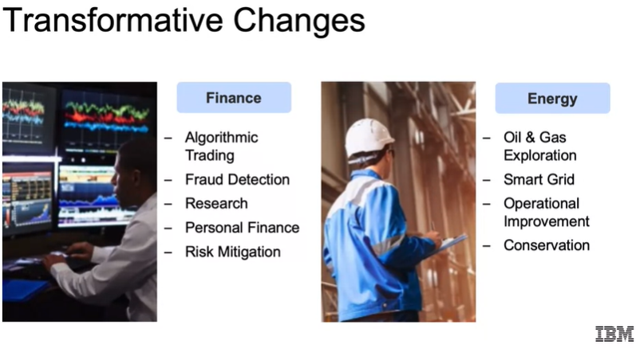 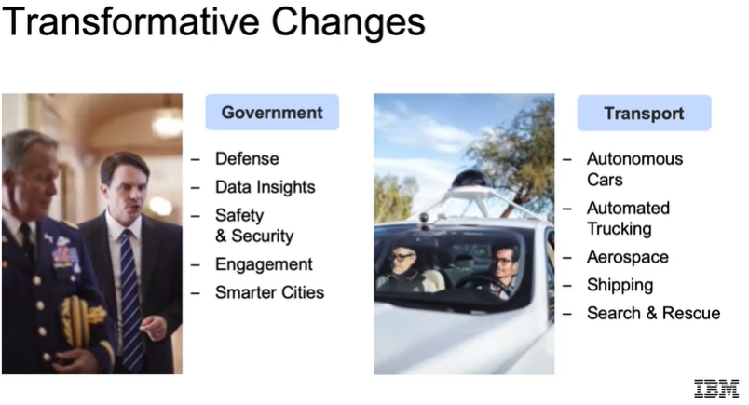

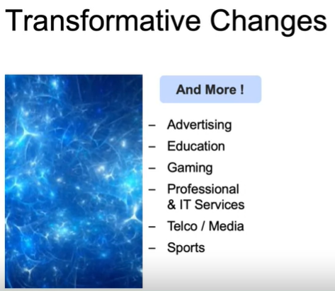

**Applications**

Let's think about artificial intelligence regarding our personal transportation. So, figuring out the shortest distance between two points is a classic problem since before the introduction of artificial intelligence. And today, we also add the complexity of knowing traffic information or predicting it based on historical data and weather conditions, so on and so forth. Google and Waze have been able to incorporate all these factors to constantly improve their algorithm for fastest means of getting from point A to point B. For ridesharing, Uber and Lyft can price their rides according to supply and demand, instead of a flat rate. And the supply and demand can be updated in real-time using artificial intelligence techniques.

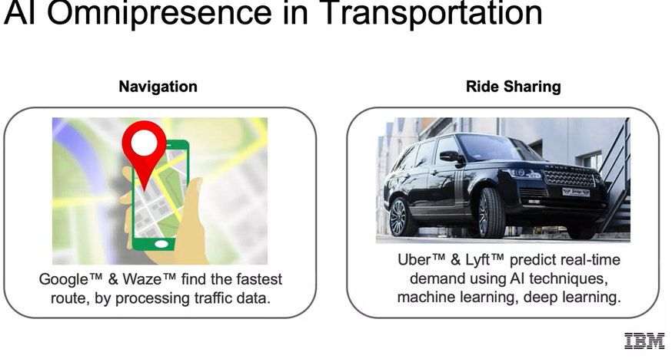

Social networking is one of the newest businesses that is exploring artificial intelligence. Artificial intelligence can now identify content relevant to an individual, recommendations for people or groups to connect with targeted advertisement delivery. We also see image recognition and sentiment analysis to ensure that the content is appropriate mood that we want to be served. Artificial intelligence has been successful at identifying the sentiment of content, such as the review of a restaurant. Is that a positive or negative sentiment?

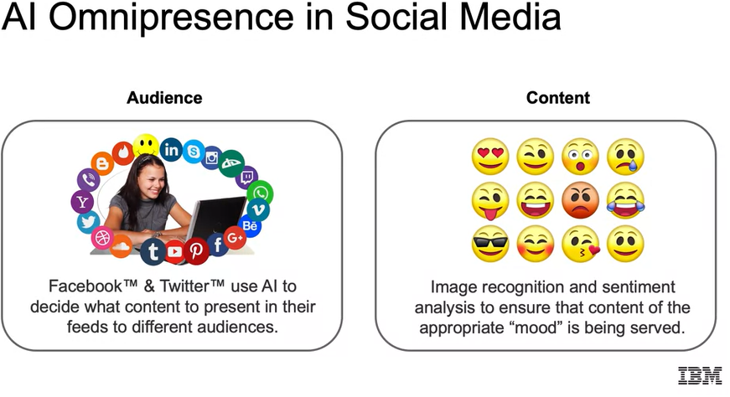

We have in our daily life. We think about natural language processing. Today, we have products, like Siri on our phones or Alexa in our homes that can recognize our voice and answer questions or do tasks for us. With object detection, this is important for self-driving cars. Facebook can recognize faces and pictures and suggest who that person is so photos can be easily shared with friends.

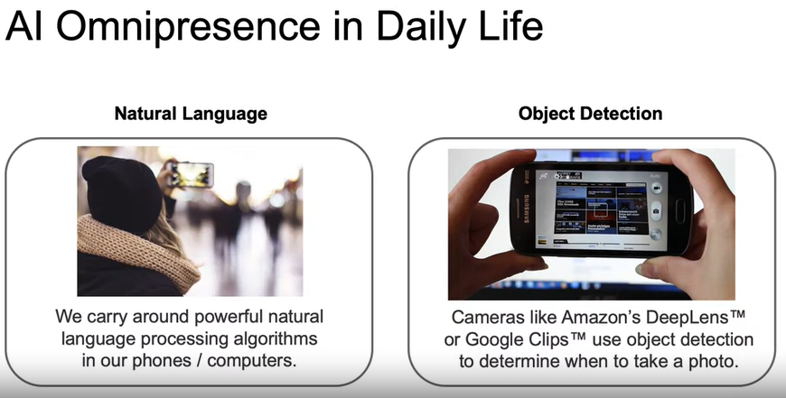

And with computer vision, when we talked about this pretty thoroughly throughout, we saw how deep learning is proven to work for image classification, able to outperform humans and many image classification tasks. And today, we see it doing live detection, which is going to be very important as we try to roll out self-driving cars.

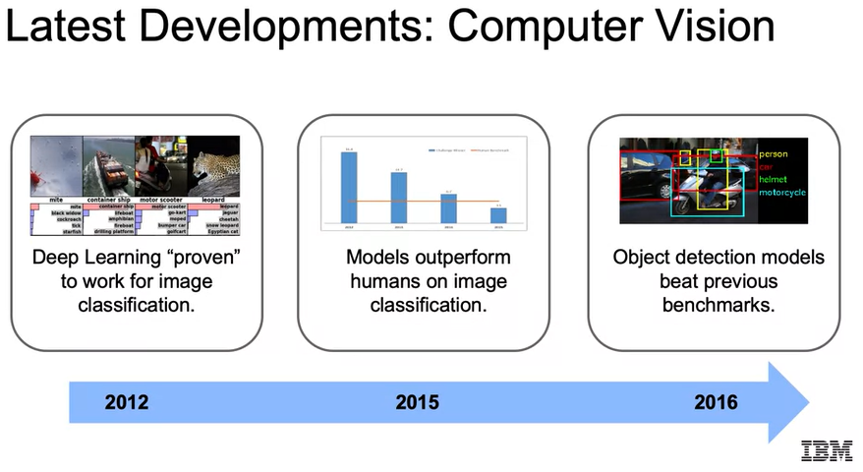

And moving into the future, how we can use this for things such as abandoned baggage detection. We can automatically detect when baggage has been left unattended, and this can potentially save lives. And this system is going to rely on cutting-edge object detection ran in real time. So, we see how this can actually be applied in real time using artificial intelligence.

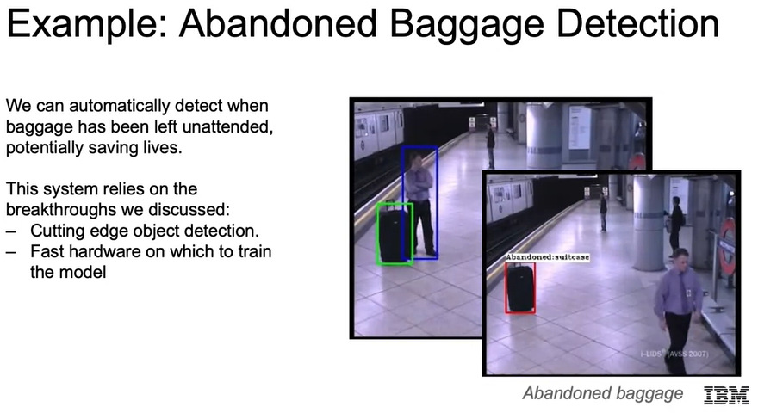

**Machine Learning Workflow**

In this course, we're going to assume familiarity with Python libraries, for example, NumPy or Pandas, working with Jupyter Notebooks. We'll also assume familiarity with basic statistics including probability, calculating moments, and Bayes' rule. Our examples we'll use iPython generally using our Jupyter Notebooks. We'll be using the following libraries: Numpy for numerical analysis, Pandas for which we're going to read in our data into Pandas Dataframes, Matplotlib and Seaborn for visualization, Scikit-Learn for machine learning, and then TensorFlow and Keras for deep-learning specifically.

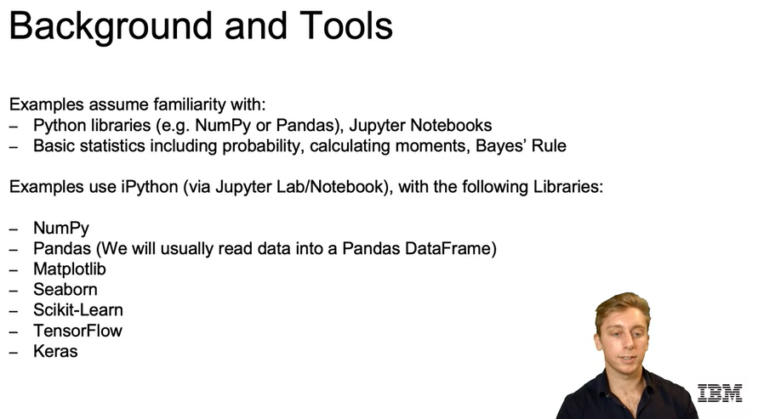

Let's dive into what our typical **machine learning workflow** will be. Our first step is going to be the **problem statement**. What problem are you trying to solve? I think with image recognition, it'll be the ability to classify different objects such as different breeds of dogs. Then it's going to be **data collection**. What data do you need to solve it? For the example we just posed, we would need more than a single picture of each breed but tons of labeled data for pictures in different lighting, from different angles that are all correctly labeled. Then we do our **data exploration and preprocessing**. How should you clean your data so your model can use it? So again, with the image classification example, we then want to dive into our data, look at the distribution counts, look at heatmaps of the densest points regarding our pixels. Also, for planning to use deep learning we will want to convert our pixels to multidimensional arrays given the scale for each color. Then we're going to go about actually **modeling**. So, we're going to want to build a model to solve our problem. We can try our model now. Probably start with some basic baseline model then we're going to **validate**. Did we solve the problem? We would check with the holdout set. So, we'd have a set of pictures that we haven't trained our model on and see how well we were able to classify that image given the labels that we have. Then comes **decision-making and deployment**. So, assuming that you did a good job in getting a certain range of accuracy, you would then move forward with communicating with stakeholders in regard to how to put this in production or actually just move forward and putting it into production.

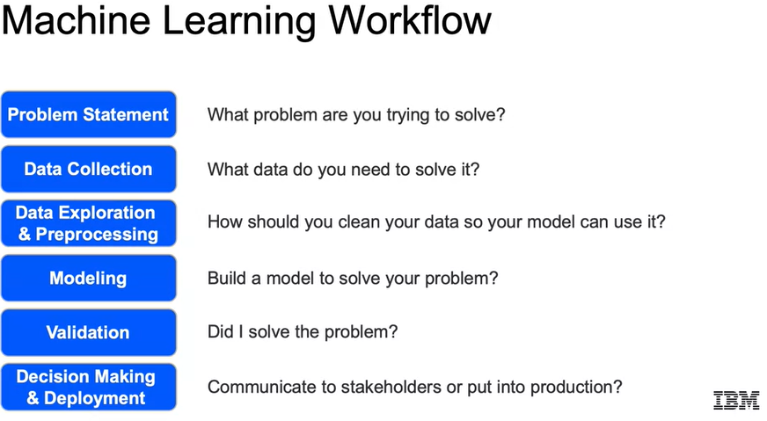

We'll start here with our **target** variable and that's going to be the target or value that we are trying to predict. Now it'll be easier to think of each of these vocabulary terms that we go over in the context of a spreadsheet. So here we're going to revisit the spreadsheet containing the well-known dataset on different iris flower species. We see here for each entry, the length, and the width for the sepal, as well as the length and the width of the petal and then we also have a label for which of the three species that entry belongs to. The idea being here that we'd be trying to predict later this species without having that available to us. So, the value that we're trying to predict, our target variable, which we just discussed would be the species in this example.

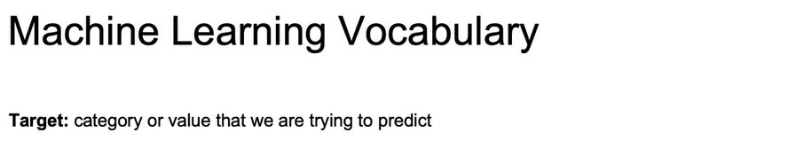

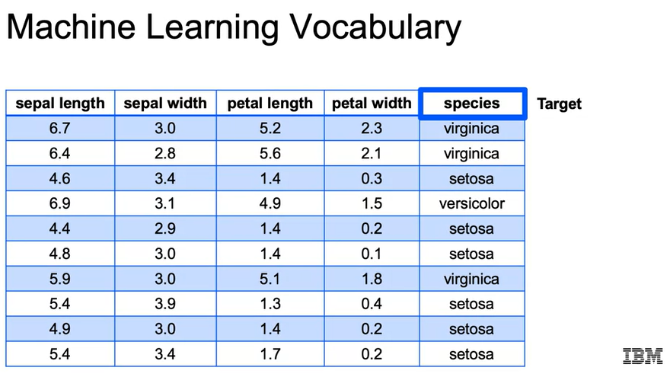

The next popular term that you'll want to be familiar with are your **features** or your **explanatory variables**. Those will be the other columns besides the target variable that you will use to predict your target variable. So later on, down the line when you're doing machine learning, when you don't have a label for your dataset, all you will have been the features. In the context of our spreadsheet, the features are going to be all the columns besides that target column. So for the iris dataset, there are four features, the sepal length, the sepal width, the petal length, and the petal width and those are going to be what are used in order to predict our target variable.

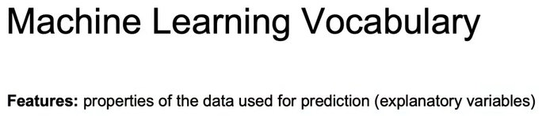

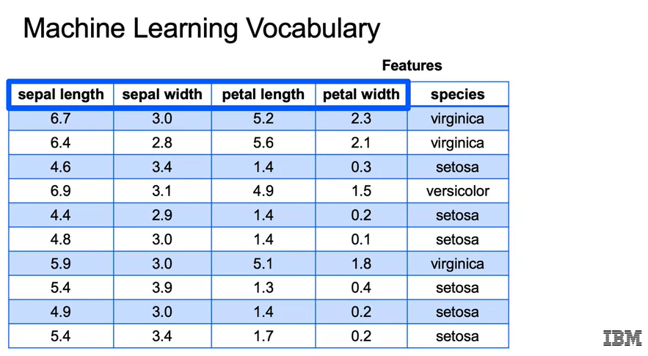

Another term that you're going to want to be familiar with is going to be an **example or an observation** and that's just going to refer to a single row within your dataset. So let's jump back into our iris dataset and think about what is an example within this spreadsheet. There are many examples in this iris dataset and all of them are used to try to train and optimize the right parameters for a Machine Learning model. So we see here one row, which is one example or another terms, one observation. You'll be hearing those terms interchangeably as you reference a single row.

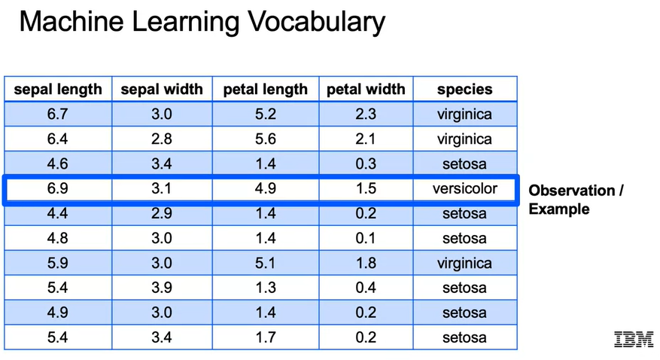

Now we introduce the **label**, and the label is just going to be **the value for your target variable**. So when we talked about an observation or an example, we're talking about the entire row. The label is just going to be just that one data point that refers to your target variable. For a label within our dataset, all that is a single example of our target variables. So here, versicolor would be an example of just a single label within our target variables.

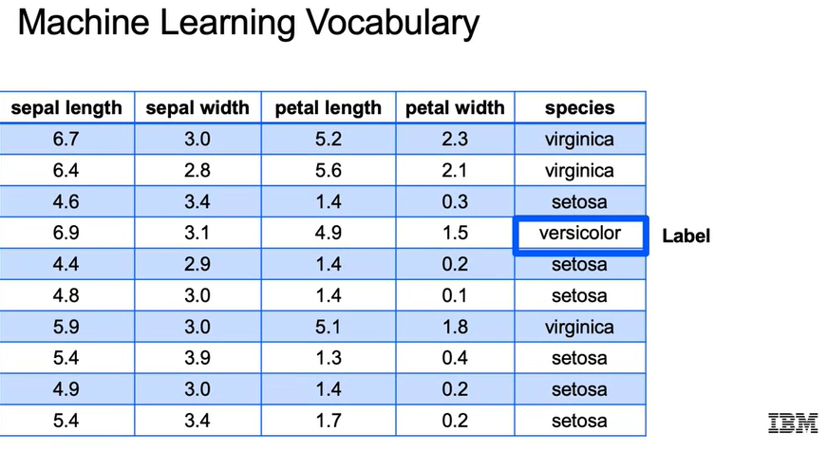

**Retrieving Data**

**Retrieving Data**

Let's discuss ways of retrieving data from different data sources. So, let's start off with reading in **CSV** files. CSV just stands for, Comma Separated Values, and that's going to consist of rows of data that are just separated by commas, or the values are just separated by commas. In Pandas, CSV files can typically be read using just a few lines of code, which you'll see below.

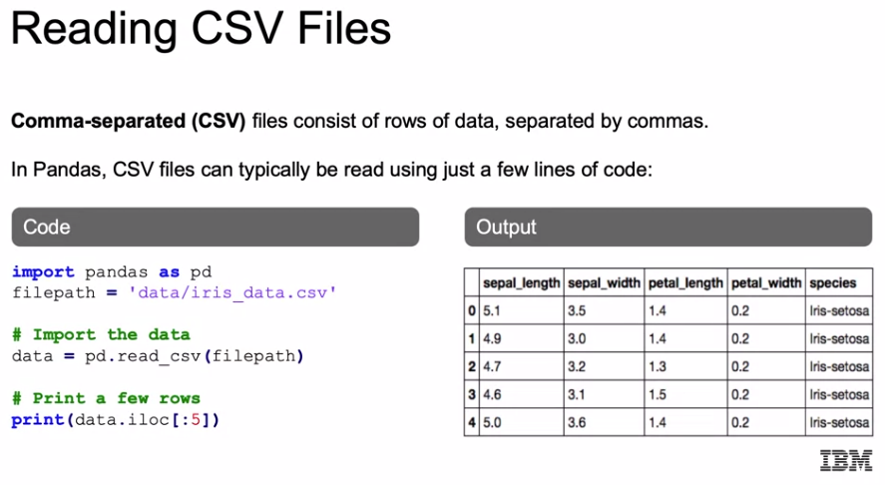

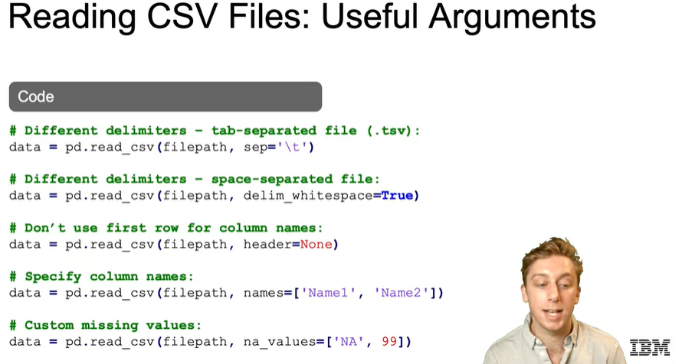

Now let's move on to **JSON** files. JSON just stands for JavaScript Object Notation, and those files are going to be a standard way to store data across platforms. You'll see them a lot for NoSQL databases, as well as pulling in from different APIs. They're meant to store information in an organized easy to access manner, and they should look similar to Python dictionaries, which I'll show you here.

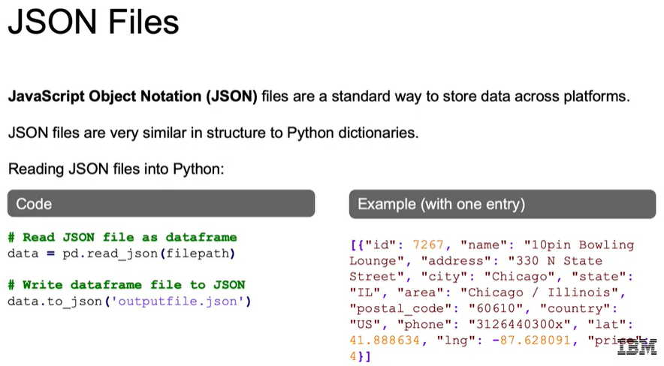

Now let's talk about working with **SQL databases**. SQL stands for Structured Query Language, and that's going to be the set of highly structured relational databases with fixed schema. Now, there are many types of SQL databases, and they'll function similarly with some subtle differences in syntax. Examples of SQL databases you may be used to are Microsoft SQL Server, Postgres, MySQL, AWS Redshift, Oracle DB, and the Db2 family for IBM. Using the right Python library with some subtle changes, you should be able to connect to the database that you use in your workforce and use the example that we see here in order to actually pull out data from your SQL databases.

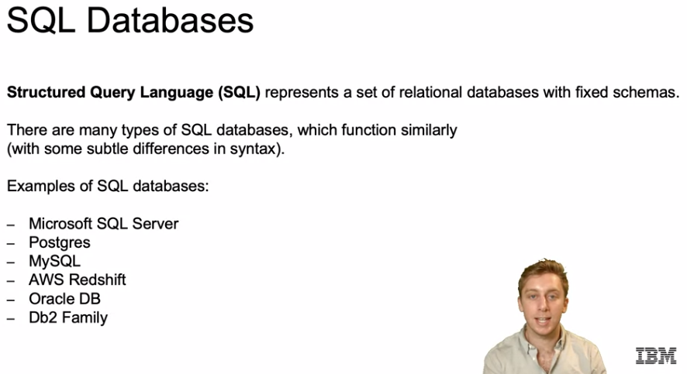

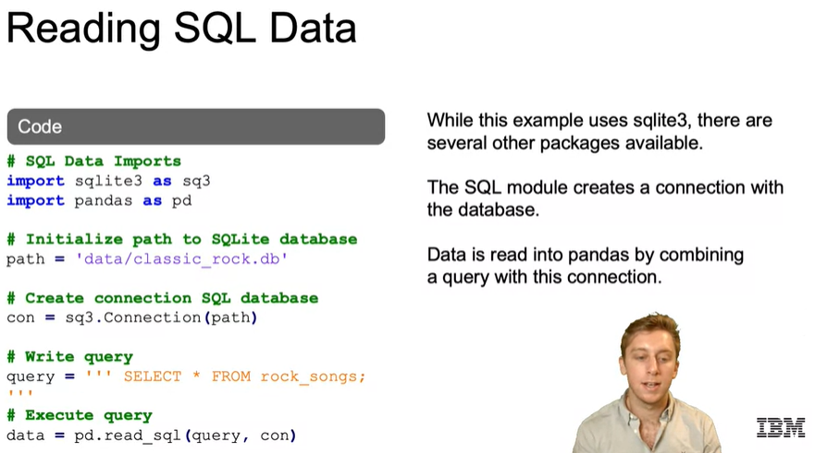

We learned how to use SQL, let's now move into working with **NoSQL databases**. Those are going to be non-relational databases and they'll vary a lot more in structure, and depending on the application, it may perform more quickly or reduce technical overhead compared to the structure of SQL format. Most NoSQL databases are going to store data in the JSON format that we touched on earlier. Some examples of NoSQL databases are **document databases**, and that's going to contain documents where each document is like one observation. We think about the JSON files, those would each be a actual document, each one of those dictionaries, the **key-value** type is going to be key and value, where the key is the lookup, think of having a primary key such as an ID and then your values would be if the ID is a person, their name, their age, their address, etc. We have **graph databases** which are going to be used for network analysis and it's great for maintaining relationships. Think LinkedIn and you have your first-level connection, second-level connection, and third-level connections, and how those are all maintained in order to see the relationship between one person and the other and there are **wide column families**, and that's going to be where all of your columns are collected together in a certain column family. So for a person, you may have their personal details in one column family and then their professional details in another column family, where the personnel would be columns such as name, location, age, and their professional column family would be something like experience, skills, whether or not they have a visa, etc.

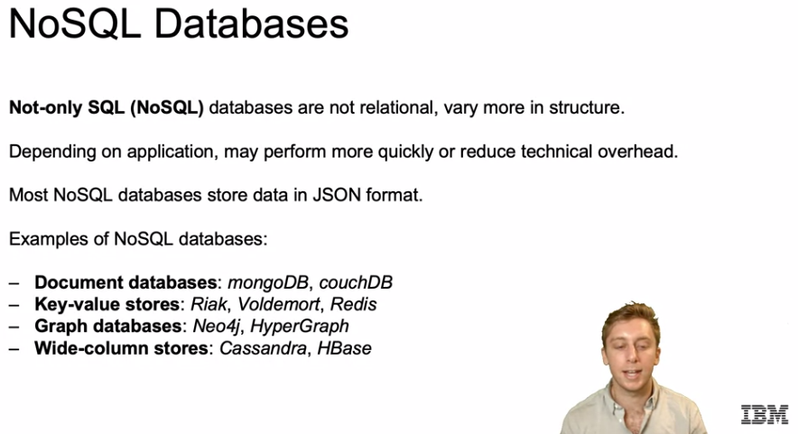

**Wide column dB:**

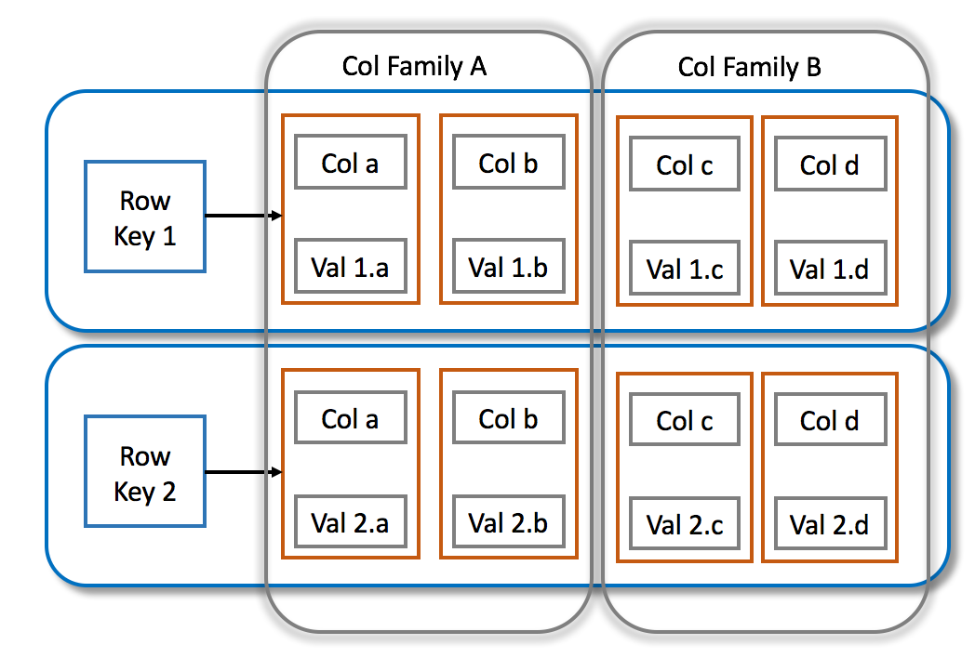

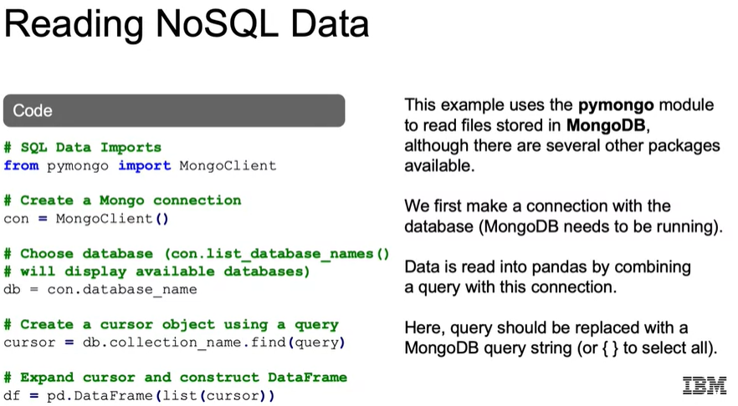

Now, let's briefly touch on working with **APIs and Cloud Data Access**. Variety of data providers make data available via Application Programming Interfaces, APIs. You can think of Twitter if you want to get the different tweets, you can actually plug into Twitter using an API. You can do the same for pulling in marketing data from Amazon, which we've done in the past for business and that makes it easy for it to quickly connect from the data source into your Python notebook. There are also a number of datasets available online in various formats.

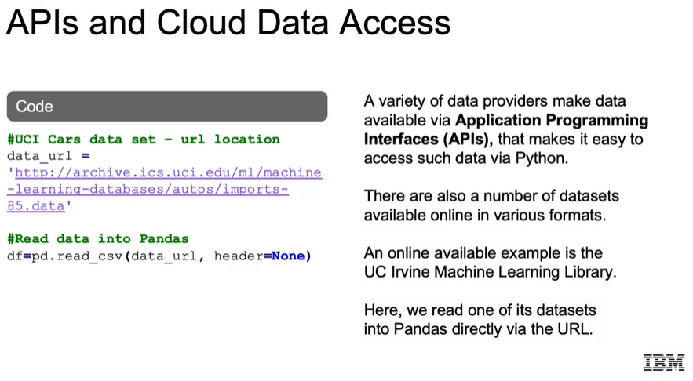

**Demo: Reading Data Demo Jupyter Notebook**

See notebook: ***01a_DEMO_Reading_Data***

**Lab Solution: Reading in Database Files**

See notebook: ***01b_LAB_Reading_Data***

**Data Cleaning**

**Data Cleaning**

We're going to go over, why data cleaning is important for machine learning? Think garbage-in, garbage-out. Our models can only be as good as our data. Some issues that arise with messy data and ways in which data can be messy in the first place. How to identify duplicate or unnecessary data and how to handle that accordingly. And policies for dealing with outliers, and the pros and cons of different methods, as there's not one size that fits all.

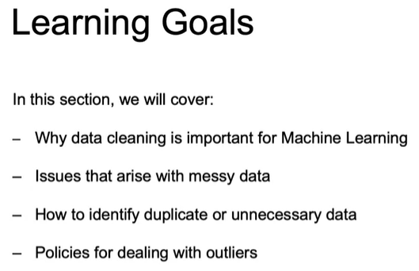

So **why is data cleaning so important**? We know that decisions in analytics are increasingly driven by data and models. And key aspects of our Machine Learning Workflow are getting depend on cleaned data.

Observations, an instance of the data usually a row of the dataset. Think if a row, an observation is not clean, we are misrepresenting to our model, the relationship between our features and our targets.

Our labels have to be labeled correctly, right, our output variables being predicted. We need to make sure that they are all labeled appropriately. We can think to ImageNet, which we discussed where we're labeling all the pictures. And if humans were labeling the pictures in order to create that dataset, if they mislabeled one of those pictures, then it will mislead our model.

Our algorithms, the computer programs that estimate models based on available data, we need to recognize that our algorithms are going to be learned, assuming the data accurately represents a real world.

Our features, the information we have for each information, if the recording of certain features are out, such as transaction amounts or locations with fraud, think about how easily that can throw off fraud detection. And then the model itself, the hypothesized relationship between observations and data. The model itself is going to be assuming that this is actual data representing the real world.

So the bottom line is, messy data can lead to "garbage-in, garbage-out" effect, and therefore unreliable outcomes given our dataset. So the first step must always be to ensure that our data is clean.

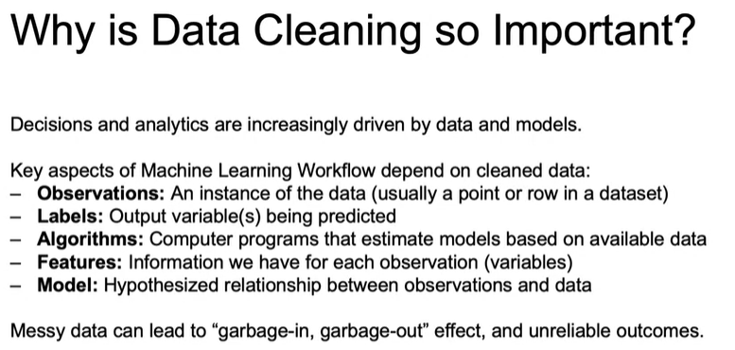

So what are some problems that companies face in regards to having clean data? Be a lack of data. For model to be successful, there must be sufficient relevant data. And if not, companies need to start by ensuring that they are collecting the appropriate data, or if needed, acquiring additional data from third parties, and making all that data accessible throughout their organization.

Now although a lack of data can hamper AI adoption, the same can be said for having too much data. When companies have too much data spread across different environments and databases, it quickly becomes a data engineering problem. In this instance, companies need to collect and organize their data to make it ready to even consider getting into leveraging it for machine learning.

And then just bad data, garbage-in, garbage-out, as we said earlier. The problem is that even though business leaders list improving the use of data as a top priority, 60% are challenged by managing data quality in the first place. So the first step for any organization to get started with artificial intelligence or machine learning, is ensuring that their data is actually ready for use.

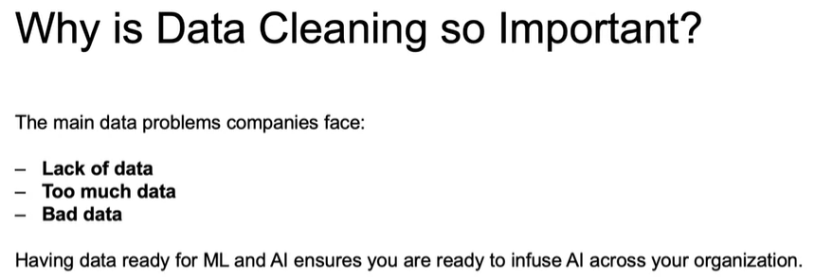

So **how can data be messy**? What do we mean by messy data and have data duplicates that can bring extra weight to observations to our model or bring in unnecessary noise? So if we think about our example of fraud, if we have a certain credit card transaction that was fraud, and that's repeated 200 times with the label of fraud, all of those features that led to that fraud will have a lot more weight because it was accidentally duplicated that many more times.

Inconsistent text and typos, data will often depend on correct spelling. You have to have no extra spaces, the capitalized versus non-capitalized letters. This will all lead to the same feature, the same value for a feature, being categorized as different values within the same feature set, even though they should be categorized as the same. And that missing data, and that should be something we'll have to deal with to some degree, no matter what. But too much in the wrong fields, can lead to an inability to use certain features, which otherwise may have been powerful predictors.

Outliers will occur that can skew a feature disproportionately and make it difficult to find the true underlying model.

We can have data sourcing issues. We have trouble bringing in data from multiple systems, or working with different database types, or trying to wrangle and combine data coming from on-premises versus on-the-cloud or many others. And trying to pull in data from all these different data sources can lead to mismatched when trying to talk about the same data when it's being pulled in from different sources.

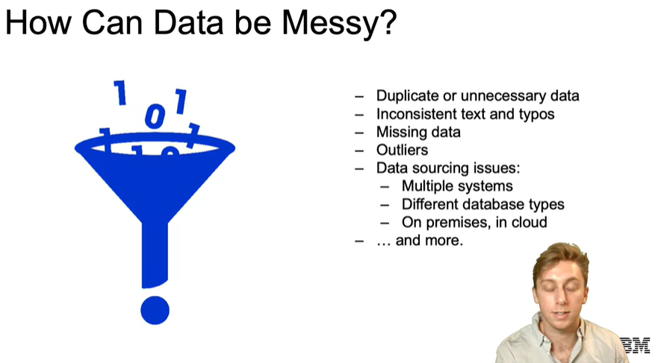

So let's start off with, **how do we work with duplicated data?** You want to dive in and see if duplicate observations are indeed needed or not. It's possible for Iris dataset, for example, to have duplicates if two flowers are indeed exactly the same, they have the same exact measurements for sepal and petal length, and they are the same species. That could happen out in the wilds, given that we're only going up to two decimal points. And we probably want to keep both those observations in place if that's happening in the real world.

Now, for trying to label pictures, for example, we probably don't want to have duplicate of the same exact picture, because that's not going to help in our labeling process at all.

It's always a good idea to look at the features and filter the data first to get a better look at the duplicates. Just in case, I would always suggest not to filter too much to ensure you keep access to the initial data that may be useful later on now.

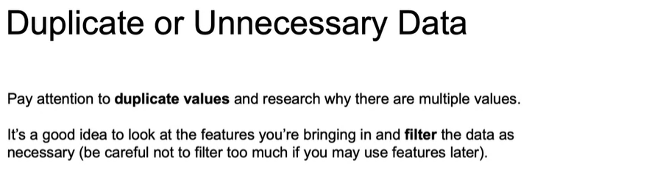

**Handling Missing Values and Outliers**

Now let's go over some best practices in handling **missing values and working with outliers**. Let's start off with dealing with missing data. Now, our models will not accept just blank values in our data, as they lack any information. We therefore are going to have to decide how to ensure that there is some information given for every single feature and label within our dataset.

So, our first option is to just **remove the data altogether**. In order to do this, we'd either have to remove an entire row or an entire column. Let's think that all of our columns are useful, so we stick to removing rows. If we think about the pros and cons of removing a full row, the **pro** here is that it'll quickly clean your dataset without having to guess an appropriate replacement value. On the other hand, the **con** is that if certain columns are missing values for many rows, we may end up losing too much information, or biasing our dataset to some reason that the data was not collected for a particular field. So again, the pro is that we can easily remove it, and if it's smaller amount of data that we're missing values for, it won't have as much of an effect. If it has a lot of rows, it could end up biasing our dataset in regards to the model that we're trying to predict.

We can **impute our data**, and that means that we would be replacing our null values with either the mean or the median, or even a more complex estimation of the value. The **pro** to this is that we don't lose full rows or columns that may be important to our model, as we would have when we try to remove full rows like we said. The **con** is that we add another level of uncertainty to our model, as this is now based on estimates of what we think that true value for that missing value should have been.

Final option we have is to **mask the data**, so that all of our missing values are their own category. This would be under the assumption that missing values are actually indicative of useful information. If we imagine a survey given by phone, and the last question is repeatedly blank, that may mean that the person hung up before getting to that last question, and marking that as missed last question may actually provide extra information for our model. So the **pro** to this is that again, we don't lose any rows or columns that may be important to our model. The **con** is that we, again, add another level of uncertainty to our model as it's now based on the assumption that all our missing values are alike.

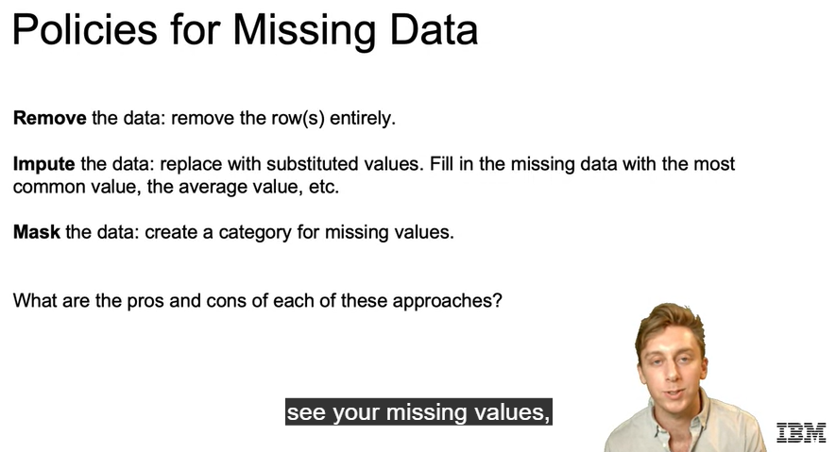

Now, let's touch on **outliers**. An outlier is an observation in data that is distinct from most other observations. Typically, these observations are aberrations, and do not accurately represent the phenomenon we are trying to explain through to our model. Imagine we're trying to predict sales, and all of our values are between 10 and 50, and then we have one week where our value is 3,000. If our model is just to take the average, we may end up with values between 10 and 50 will put us somewhere around 30 when we're trying to predict moving forward. That 3,000, assuming we have a smaller dataset can push that average value up to 200, 300, whatever it is, which is much higher than the value we'd actually predict given our historical values. So that outlier will throw off what our actual prediction would be. If we don't identify and deal with outliers, like we just mentioned, they'll have a significant impact on our model. It'll be important to remember though, that some outliers are informative and provide insights into the data. You don't want to just remove that 3,000 value, and not look into it. There's often very useful information, probably more useful than your other values between 10 and 50 to tell you why that 3,000 happened, and give you extra information that may explain what's actually happening in the real world.

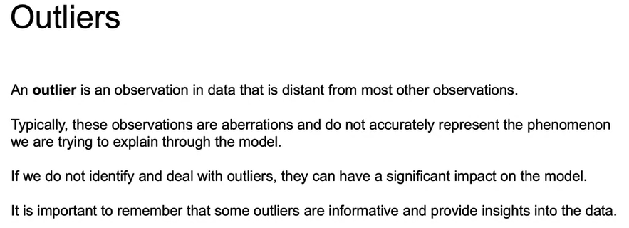

So **how do we actually find outliers?** We can use plots. Here we see both a histogram and a density plot. We can also use a box plot in order to see the interquartile range, the median, a defined min and max value for which outside of that we will have outliers. We'll have standardized, deleted, and studentized residuals which we'll define in just a few slides.

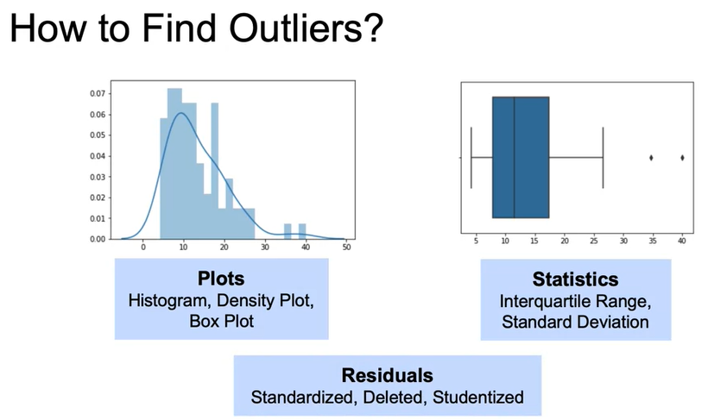 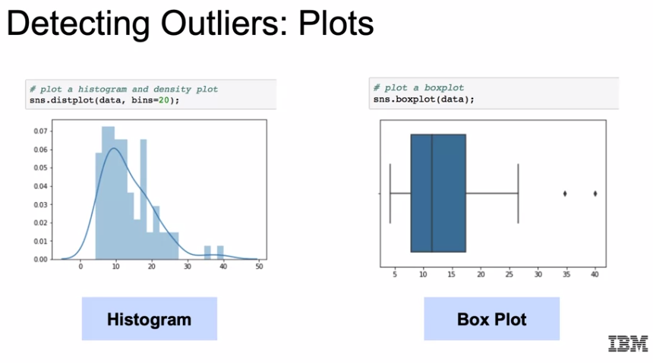

Now, how do we end up mathematically getting to what we see here, these outlier points instead of the min/max going all the way to the range of the full dataset? We're going to use np.percentile to define from our data the 25th percentile, the 50th percentile, and the 75th percentile, and we'll label them accordingly, the variables that is. Then iqr is going to represent our interquartile range, which will be just the 75th percentile, which we said as q75 minus the 25th percentile, which was q25. The idea will be that our lines on our boxplot should represent both that min and max defined, and anything outside either the min or the max here, we just have the max or we count it as outliers. If x is greater than that max value, then we will define that as an outlier.

* Percentil: <https://curiosoando.com/que-son-los-percentiles>
* Iqr: <https://economipedia.com/definiciones/rango-intercuartilico.html>

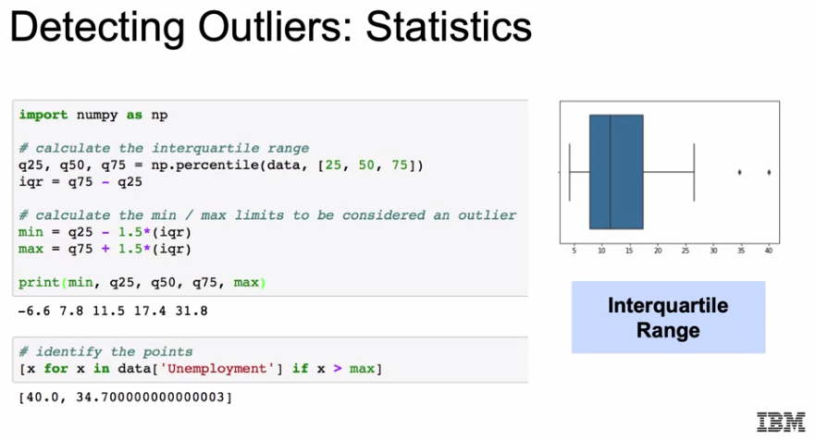

Another way that we can detect outliers is to work with the **residuals**. Now, what are residuals? That's going to assume that you have a model and it'll be the difference between the actual value and the predicted value given your model, and they are going to represent model failure. What are some approaches that we can use in order to leverage residuals, in order to detect outliers?

* We can use the **standardized residual**, which is, it's going to take our residual and divide it by the standard error. The idea being here, if you have outcome variables between 10 million and 100 million versus between zero and five, being off by four means much different thing given those different outcome ranges. So we want to standardized it according to those ranges.
* Next we can use **deleted residuals**. What you can do here is to remove that observation from the dataframe. Once you do that, you see what the new model will predict and see if there's a big difference between the original model and the model with this deleted observation.
* Finally, there's going to be the **studentized residuals**, or sometimes called the **externally studentized residuals**. This is essentially just going to take our deleted residuals and standardize them as we saw in our first standardized residual discussion. So it'll take out one of those observations. Once you take out that observation, you see the effect on the model and you standardize that according to the range of that model.

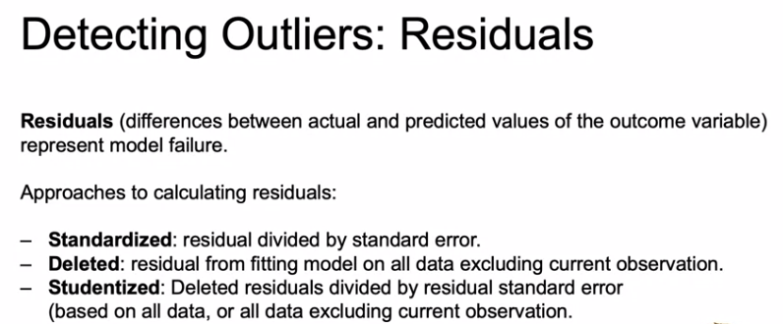

So what are some things that you can do once you do detect an outlier? You can **remove them altogether**. The **pro** to this is that you no longer need to worry about their effects, but you may have lost, not only an important value, but the entire row related to that value. You can **assign a different value** to the outlier. Again, then you don't have to worry about the effects of this outlier on your model. But again, you will be losing what may have been an important value, but this time not having to lose the remainder of the row. We can **transform the column** that actually had the outlier. Once you do something like a log transformation, that outlier, given the new range, may no longer be an outlier.

We can also **predict** what that value would have been. We can do that either by using **similar observation**. So looking at the other observations, the other features that were not outliers, and see what the outlier would have been if it's similar to those observations. We can also use **regression** and that can do a good job of also predicting what that value would have been given the other features. This may do a good job of saying what that value should have been if we have enough other data, but we may lose important value, again, similar as we discussed with all the other ways of replacing our outlier. It's going to require a lot more work than any of our other methods of working with outliers. Then finally, we can just **keep that value**. The idea being here that you will probably want to use a model that is resistant to outliers.

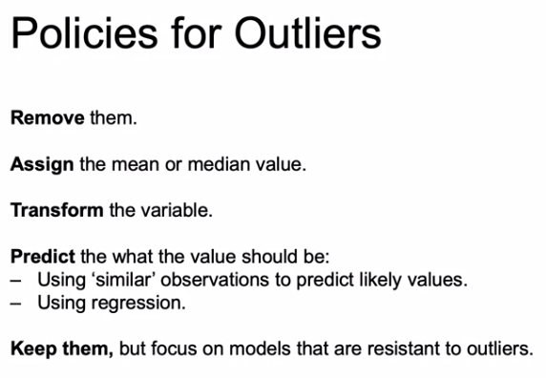

**Exploratory Data Analysis**

**EDA – Part 1**

In this section, we'll move on to the next all important step in our machine learning workflow, namely **Exploratory Data Analysis, or EDA**.

**What is exploratory data analysis?** EDA is going to be the approach to analyzing data sets to summarize their main characteristics, often with visual methods, and as we'll see what's statistical summary is as well.

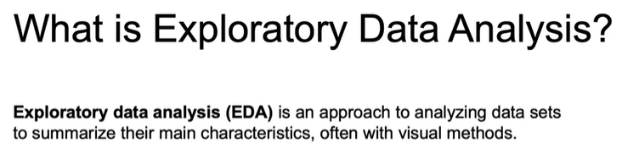

**Why is this EDA useful?** I want you to think of it as your initial conversation with a data before getting started. It's getting to know you face with your data set. So this will determine if the data that we're looking at actually makes sense, or if we need further cleaning, or if more data is actually needed. EDA will help us identify patterns and trends in the actual data set. Sometimes this can be as important, if not more important than the actual findings from the modeling.

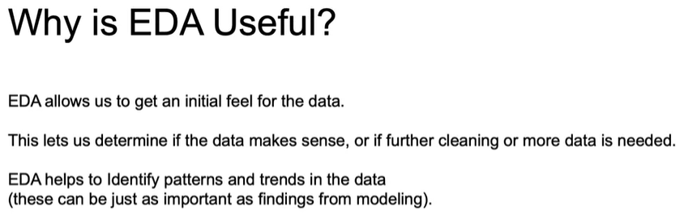

So some summary statistics that we do, typically, deal with EDA looking at the average, the median, the min, the max, the correlations between different columns. Or we can look at the visualizations given our columns. We can look at histograms in order to see the distribution, the scatter plots to see the correlations or the relationship between two different columns, and box plots again, to look at that distribution and to identify outliers and many others. When we're doing data wrangling, or if we're looking at those summary statistics, we're generally going to be using the pandas library, and then for visualization, we will rely on the libraries Matplotlib and Seaborn.

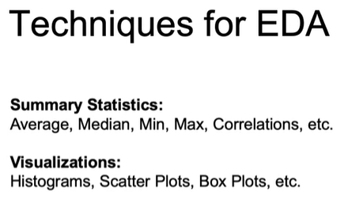 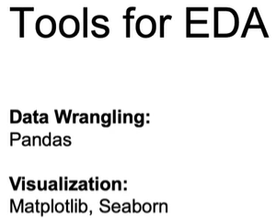

So an example of EDA for job applicants summary statistics, suppose we want to examine the characteristics of our job applicants. We can look at the average, we can take the average of all interview scores or maybe break it down by city or job function so that we can compare applicants scores to the averages of their direct competitors. We can look at maximum values, or here are more like the mode value to see which words are most common from all the applicants given the application materials. Finally, we can look at correlations. We can look at the different correlations between technical assessments and the years of experience of our applicants, perhaps breaking it down, again, by type of experience. So we're comparing against their direct competitors, and this will allow us to see if there's any type of initial relationship between different columns, and that may be worth being immediately being aware of before doing any modeling.

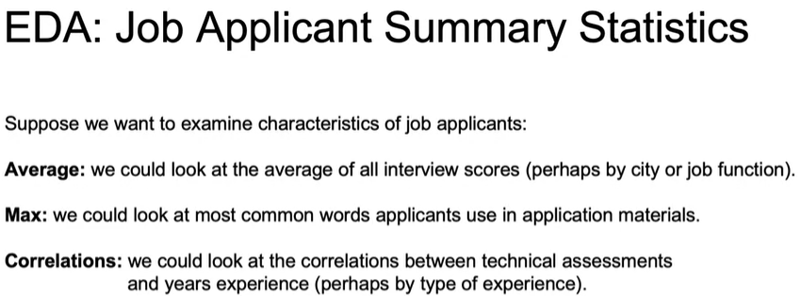

Let's discuss sampling from Dataframes for just a second. Now, there are many reasons to consider random samples from our Dataframes. For larger data sets, we may want to shrink down to a random sample if the computation would take too long for the larger data set. We may want to train models on a random sample of the data and hold out another set for testing later on. We may also want a sample that is indicative of the proportions of the different observations of our outcome variables. Now, what do I mean by this? Let's say that you are working with a data set that's supposed to determine whether or not a certain person has a terrible disease and only one percent of the entire population has that disease. If you want a sample, you also want to ensure, assuming there's only one percent that have the disease, you want to ensure that you keep that proportion in your sample data set. So you want it to be a similar proportion, you want to ensure that you don't end up with a sample that doesn't have anybody with the infection, which is possible or with an over representation of that disease. So that's where this is called stratified sampling may come into play.

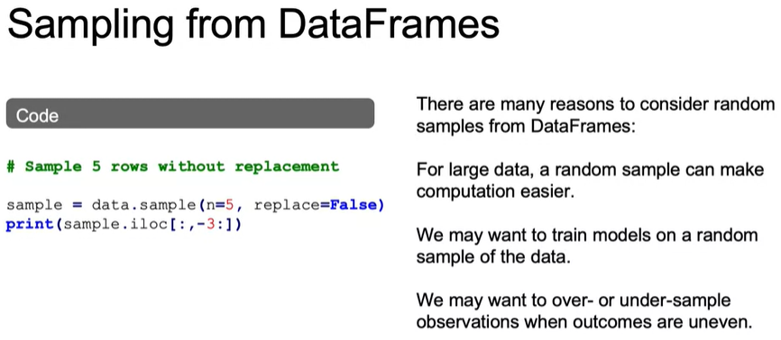

**EDA – Part 2**

Let's briefly talk about some of the **data visualization** libraries that are available to us. We have **matplotlib** which will be the main library used to create plots and graphs in Python. And it has a lot of flexibility and features that you can tweak and definitely very useful and the foundation for doing visualizations within Python. Now, **Pandas**, which we've seen so far actually offers a convenient wrapper function around the matplotlib library. So plots can be created pretty easily on fly compared to working with the raw version of matplotlib, and it's very convenient, but it's less flexible and less powerful compared to working with the original version of matplotlib, but often it's good enough.

And then finally **Seaborn** is a library built on top of matplotlib as well, and it creates very pretty plots. Has shorthand methods to create statistically interesting plots such as linear model plots, pairwise correlation plots and many others, which would otherwise take a long time using just matplotlib. Also once imported Seaboard preferences are Incorporated by matplotlib. So if you import Seaborn and then go back to using matplotlib, it would look like you're still within the visualization format that Seaborn has.

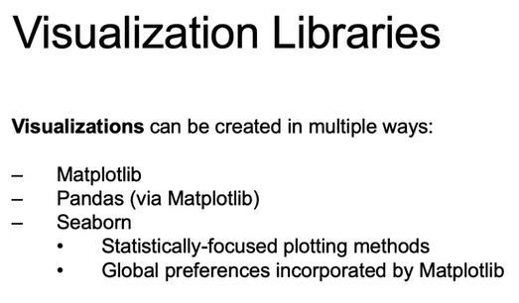

Now let's dive into actually creating some of these plots will start off here with a basic scatterplot with matplotlib. We want to plot the sepal length, so we're pulling in that column sepal length, and we are also pulling in sepal width remember using a scatter plot. So we're looking at the relationship between the two, so we see the scatter plot between sepal length and sepal width.

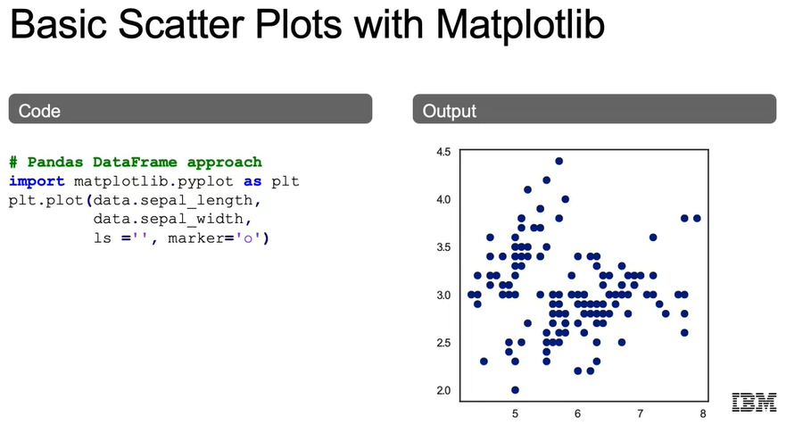

Now what about working with scatter plots with multiple layers, maybe want to differentiate it by color?

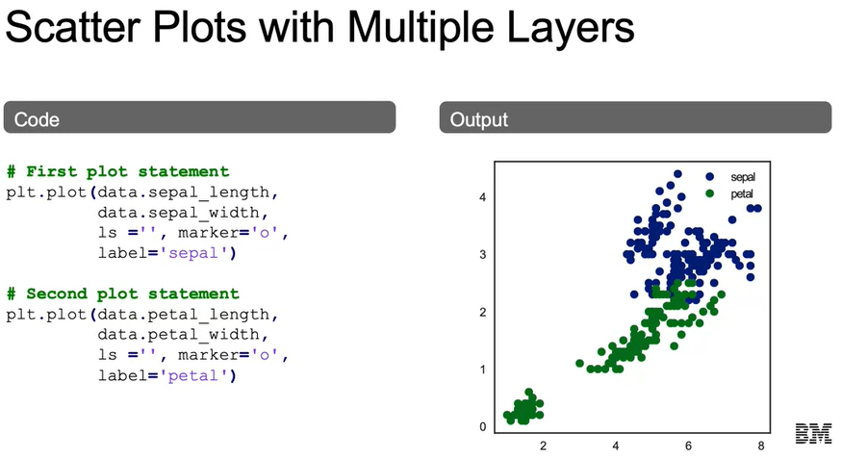

We also have the option of plotting a histogram, here we'd only want to pass in one column. The output that we see here on the right that gives the distribution of this actual column.

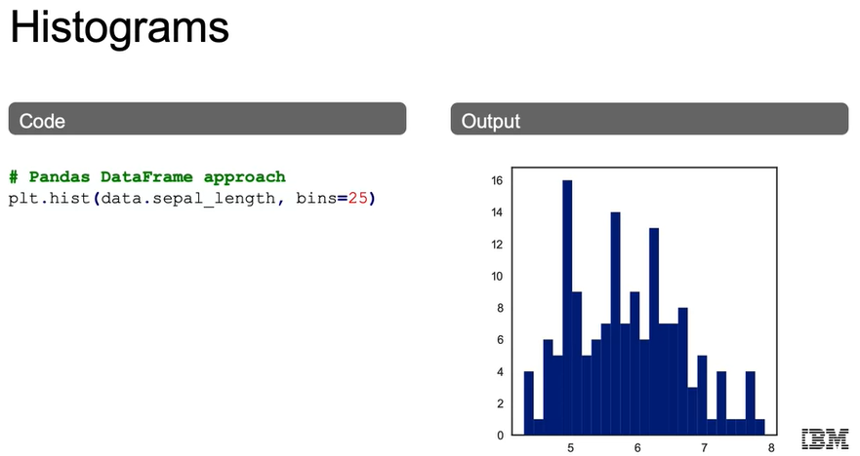

So some ways that we can customize plots, here we're using the plt.subplot so that we have fig in ax separate. So we're going to look at the different widths and we're going to have a bar plot to represent each one of those widths. We have the title like we mentioned y label and x label values 1 through 10, and each of those representing the different sepal widths for first 10 values.

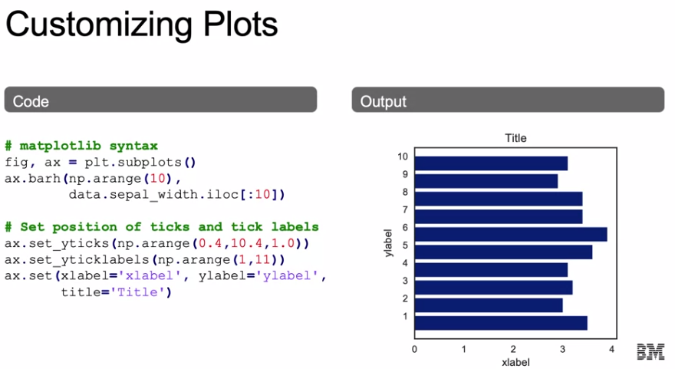

Now let's talk about how we can use the Panda Syntax for plotting. We're going to group by are different species by our target column, and we're going to get the mean for each one of our different features, pedal length pedal with sepal length and sepal width. And what does that look like?

We see here the output where we have our x values being the different species starting with setosa, then versicolor then virginica. And we can see the average value for each one of these starting with sepal length and with red, and then we have several with in blue according to the colors that we specified earlier.

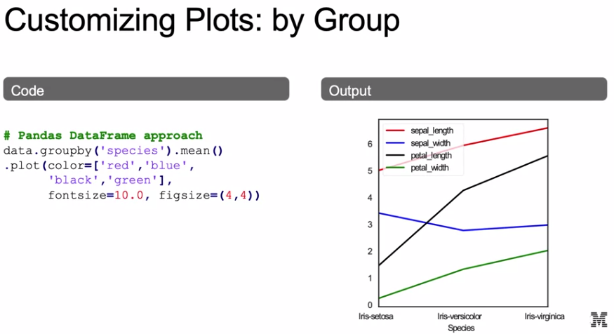

A very useful feature of Seaborn is going to be the **pair plot**. We see here that it's going to create a scatter plot between each one of the features and the other feature. So we see sepal length compared to sepal width in the first row second column, and we're able to see that relationship. With that because we set the hue equal to species, we're able to see that relationship broken down by color according to the different species. Now, obviously if you look across the diagonal if we were to create a scatter plot with one value with itself, we just have a straight line.

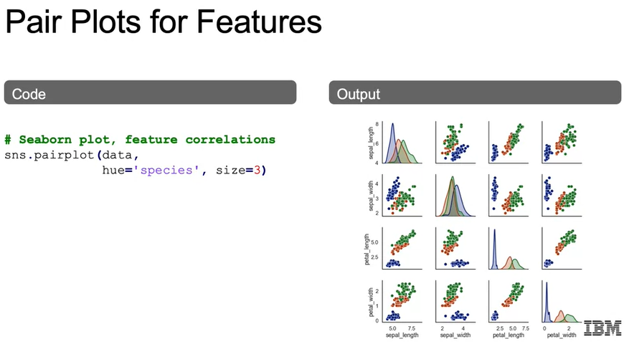

So let's zoom in just on what that scatter plot actually looks like when we're looking at the pair plot. So we're able to see a visualization now of the correlations as well as the histograms across all of our different columns, which is what makes this so powerful here focusing in on the scatter plot. We see petal length versus sepal width in that top right corner, and we see the relationship and we are also able to break that down by the different species. We can imagine in a business case that we may want to see the example of the effects of different features such as ad spend on revenue and we can see that relationship. As well as the distribution of ad spend and the distribution of revenue for our actual data frame.

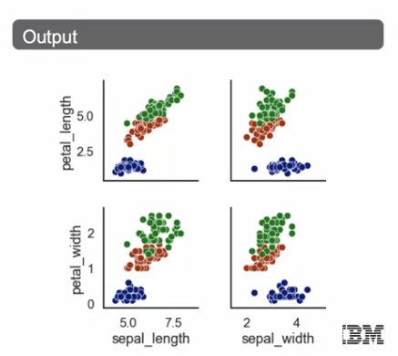

Another useful feature of Seaborn is working with the Hexbin plot. It's going to be similar to a scatter plot, but it's actually going to give the density of where the most similar points are being found. So we see these much darker hexagons where there's going to be a lot denser amount of values there compared to the lighter hexagons where there's not as many values there. So it's able to also show where most of these values are actually falling, and with that we can also see the histograms of both the sepal length and sepal width on the top and to the right of our graph here. And again, we can think about the relationship between ad and revenue and we'd be able to see the distribution of each, as well as saying where each of those values are most likely to overlap.

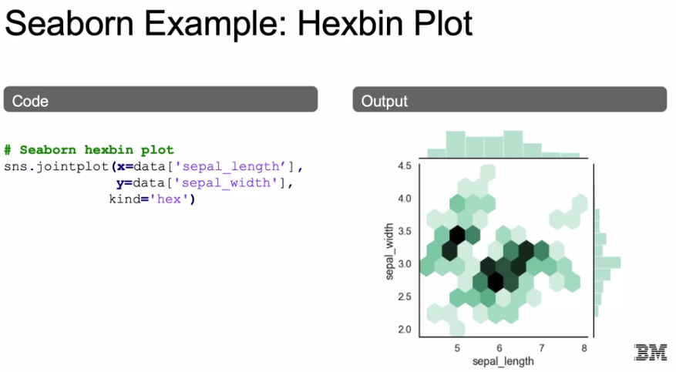

Finally if we want to really break it apart and sing at it across different categories, so similar to how we do a somewhat of a group by, we can use our **facet grid** we pass in our data. And we're going to map in a histogram of the sepal width for each one of these species.

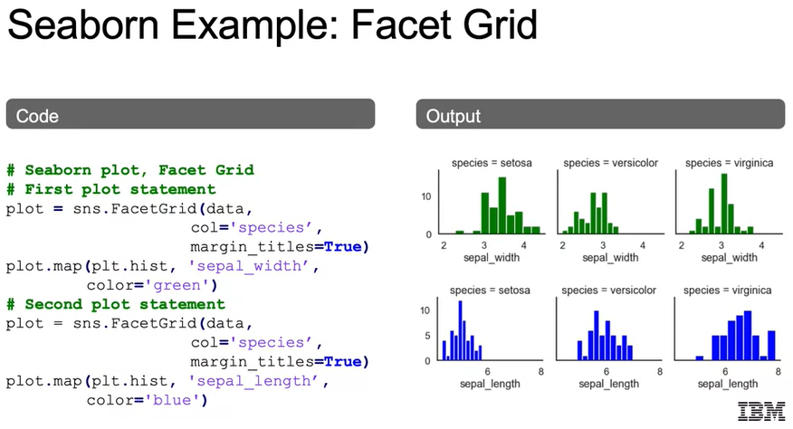

**Solution: EDA Notebook - Part 1, 2, 3 and 4**

See notebook: ***01c_LAB_EDA***

**Feature Engineering and Variable Transformation**

**Feature Engineering and Variable Transformation – Part 1**

In this section, we'll discuss **feature engineering** as well as **variable transformation**. At this point, you've learned to retrieve your data from the available data sources, clean your data set, and do some exploratory data analysis, EDA, on your data. Now, before we move to modeling, we'll most likely need to adjust the raw data coming in to optimize model performance. So what are related learning goals that we'll cover in this section?

* Talk about **feature engineering and variable transformation**. And we very briefly touched on variable transformations during our data cleansing session and how a log transformation may help you with outliers by changing the distribution of that data.
* We will do some **feature encoding**, because all inputs for model must be made numerical. So we'll work here to show how we can actually encode our categorical data so that can be included in our models.
* And then finally, we'll discuss **feature scaling**, as real world's raw data in our data sets are generally not going to come in on the same scale as one another for each one of the features. And this will prove to be an important property for many of our machine learning algorithms.

So models used in machine learning workflows will often be based off of some assumptions about the data. A common example is a linear regression model. And this is going to assume a linear relationship between the observations and our target outcome variable. All we want to take away here is that if we're going to use linear regression, which will be very important as it'll be the foundation for many of our machine learning algorithms moving forward. **We want to assume that there's actually a linear relationship between our predictor variables and our actual outcome variables**.

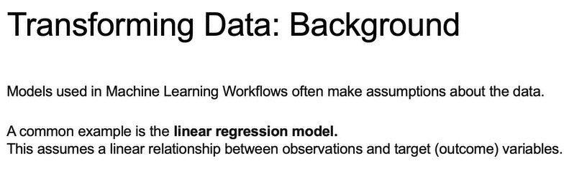

So an example of a linear model relating a feature variables, variables x1 and x2 with a target label variable y, is what we see here. Here beta, beta 0, beta 1, beta 2 are going to be the parameters that we will hopefully learn with our model. An example that you can think of is, what we'll use also in the later graphs, is box office returns. And you can think of x1 as the cast budget and x2 as the marketing budget. And then beta 1 and beta 2 determining how much the cast budget and the marketing budget will actually help in predicting what the revenue will be for that movie.

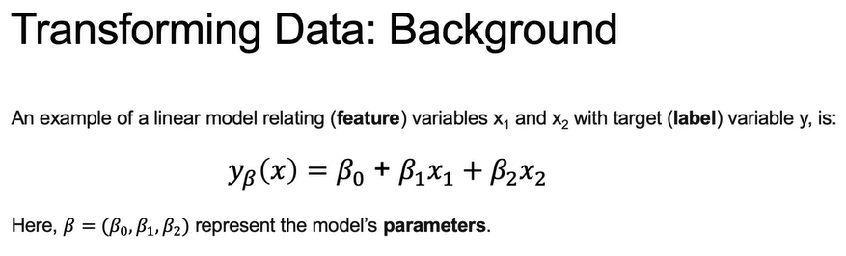

Now, think of linear as just being an addition of each one of the model parameters multiplied by coefficient. And as well see, we can actually transform each one of these parameters to ensure a linear relationship. So if you think about the different x1's and x2's, we can actually transform x1 and x2 to something else and then still have a linear relationship by using just a coefficient multiplied by that transformed x1 and x2.

Now, the mathematical theory behind a linear regression is going to assume that our residuals from our model are going to be normally distributed. Now, often the raw data that we get, both the features and the outcome variable, can be negatively or positively skewed, as we see here.

And in real life, that data can come in all shapes and sizes. And data transformations can help the algorithm find a better solution that will end up having residuals that are actually normally distributed.

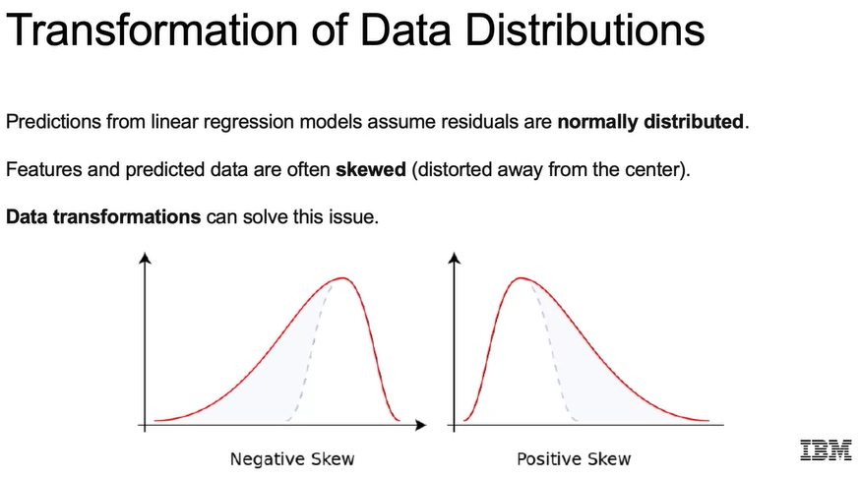

So some ways that we can transform our data. We see here some code bringing in log and log1p from NumPy. **log1p** is just going to be log, except you add one because you can't take the log of zero, so in case you have zero in your data set. And then the **boxcox** is just a more complex way that will find the ideal way to transform from a skewed data set, such as the right skewed data set we see here, to a normal distribution.

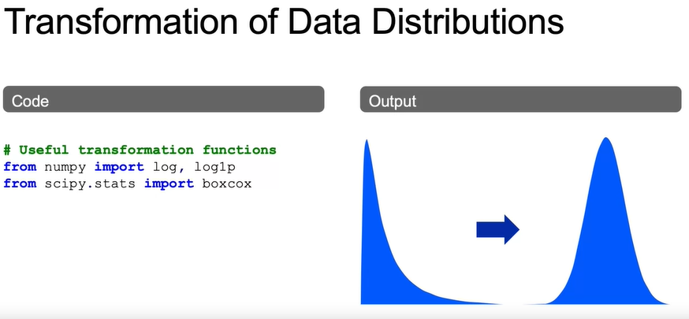

So we see here an example of how we can apply the log transformation to a positively skewed data set. So we start here with a positively skewed data set. And then we see once we take the log of that data, we end up with a data set that is more normally distributed.

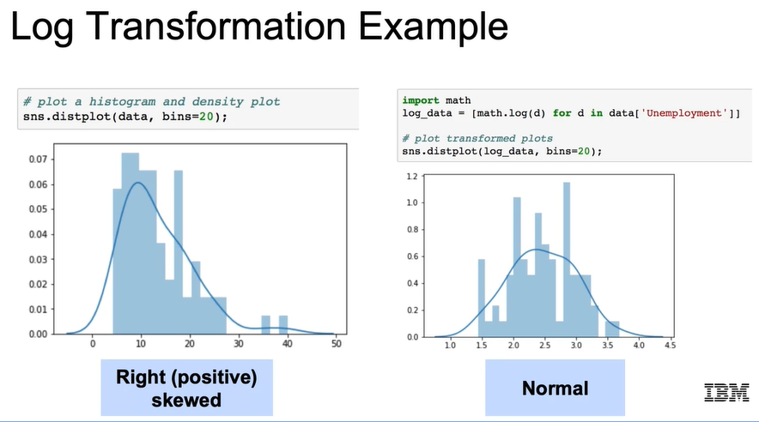

Now, log transformations can be a useful way to find a linear relationship when the underlying raw data may not actually have a linear relationship.

So the resulting algorithm will still be a linear regression since the outcome is still a linear combinations of the features. Just the features now have been transformed, feature engineering, variable transformation, so that we can input those into the linear regression. Now the linear regression involves a linear combination of our new features, one of our new features being the log(x) rather than just x.

And this is a common example when we have a relationship maybe with diminishing returns. Such as a larger box office probably will not have a linear relationship with the budget, but rather it would have diminishing returns. **So larger the budget, after some time, you probably won't get as much return on your box office. So that isn't a linear relationship, but it may be linear with the relationship of log(x)**.

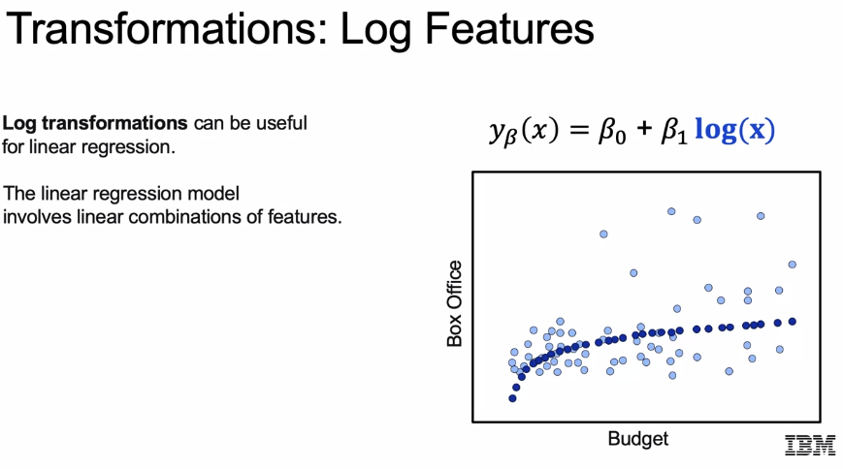

Similarly, we can estimate higher-order relationships in this data by adding polynomial features. So it's another trick in our tool bag. So instead of only incorporating budget, we can incorporate budget squared as a feature and add more flexibility to our model and fit a linear model using these polynomial features. And again, we end up with a linear model even though we've included new features.

And again, this is the idea of, at this point, just one inflection point. So just rather than straight, it kind of curves off. Then you would have something like x squared raising the degree to two. We can even continue to extend this to three, or four, or any higher-order polynomial.

Again, we're changing our features, but maintaining a linear model, an underlying linear model just with features now transform to z plus x squared plus x cubed.

And what we see in the graph would represent not just diminishing returns, but now we have two inflection points, right? It curves up, then it curves down. And that would be the idea that after some time not only is there diminishing returns, but a higher budget may lead to less box office sales at a certain threshold.

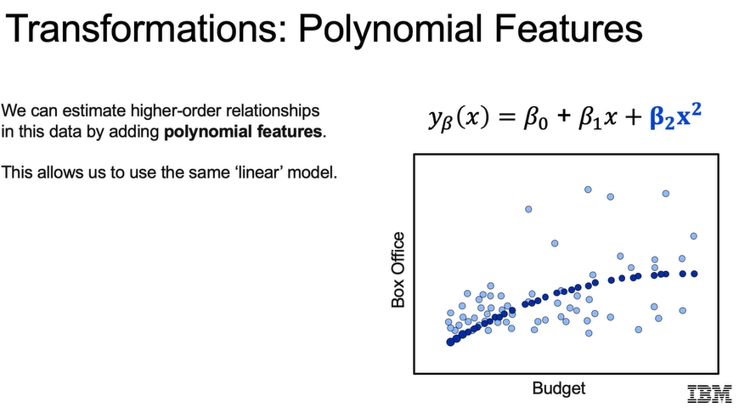 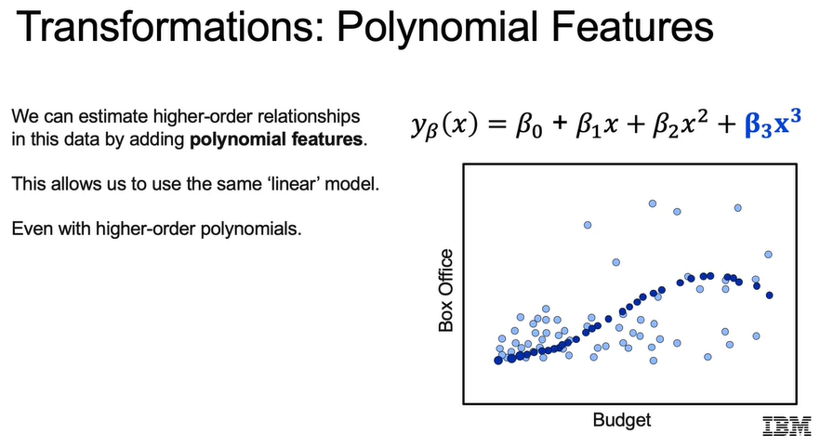

So we'll dive into this again as we look at more code, but here's an example of how we can use sklearn in order to create a polynomial transformation. So our first step is going to be to import polynomial features, import that function from sklearn.preprocessing. We will then create an instance of our polynomial features class and call it polyFeat. polyFeat is now a transformer object. What this means is that it can fit to a set of data such as x data, which we'll see in a second, and then transform it. Or it can use that in order to, what it's learned from fitting to a certain data set, to transform another data set of the same size.

So here we see we're doing polyFeat.fit and we're fitting to our X_data. And then the next step is just to, so now we have our polyFeat transformer object that is now fit to our data. And we can use that in order to transform our data from its original, so original would be something like the x that we saw earlier, to x squared, and that's going to be X_poly. Now X_poly is x squared.

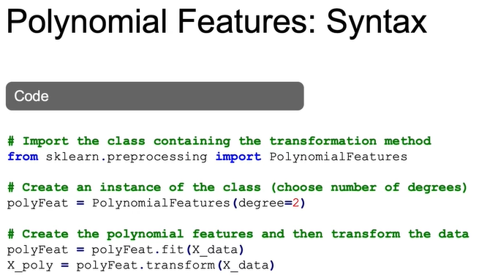

**Feature Engineering and Variable Transformation – Part 2**